Authors: Krzysztof Kwiatkowski, Mohammed Tayyab Khalid, Steve Nimo, Rares Yousif Xiaoyang Xu

EEROVER REPORT



TEAM VORTRON

**Table of Contents:**

**Part 1: Engineering Design Process**

* 1. Introduction: Outline of Project's Aims

1.1.a. Group organisation: roles and responsibilities

1.1.b. Project Management and planning

1.1.c. Testing - developing venue and equipment

1.1.d. Experimental Techniques and Methods

1.2. Design Criteria

1.2.a. Product design specifications: customer requirements

1.2.b. Concept generation and selection technique

1.3. High Level Design

* 1. Detail Design
  2. Design generation process: comparison with previous design versions
  3. Final Design
  4. Developing methods and physical realisation

1.5. Budget Management

* 1. Actions taken for budget efficiency
  2. Expenditure table

**Part 2: Technical Design and Progress**

1. Sensor Design: Circuit diagrams and functionality
2. Infrared
3. Hall probe
4. Radio
5. Motion: Motors
6. Software development
   1. Name Detection
   2. Joystick/Motor Movement
   3. Magnetic Field Detection
   4. Age Detection
   5. User Interface and Remote Control
   6. Rover Control
7. Discussion
8. Conclusion
9. References
10. Appendix

**Part 1: Engineering Design Process**

**1.1. Introduction**

Throughout the 6-week long EEERover Project, students were tasked to design a remotely controlled rover that can explore a remote planet and survey the aliens who inhabit it. There were a few key points of information given. First, the aliens emit various signals, including an infrared signal, a radio signal, and have a magnetic field. It is expected that these electromagnetic signals are decoded by sensors of the rover to determine their age, name and magnetic polarity respectively. Secondly, the terrain of the planet has a rough and uneven surface. Additionally, there will be various obstacles that emit light, which could possibly interfere with the target signals.

As engineers, we must break down this task into several main components. This will involve using 3 individual sensors to detect the infrared, radio and magnetic signals from the alien. Additionally, the structure of the rover, particularly the chassis, will have to be carefully constructed, which allows the rover to securely carry the sensors and various electronic components. Last but not least, the rover should consist of a movement system, allowing it to freely navigate through the terrain and avoid any obstacles.

**1.1.a. Group Organisation, Roles and Responsibilities:**

Team Vortron is a group of six members. Each member has been assigned a certain role within the project, all of which contributes to all the components of the project. These decisions were mainly made from personal preference, as all the members volunteered to work on a certain aspect of the project where they have a strong understanding and interest in. Roles were also assigned partially based on strengths and weaknesses of each member in the Electrical Engineering sector. This was a very smooth process which avoided any clashes or conflict within the group. The table below shows the role of each member and its responsibilities.

|  |  |
| --- | --- |
| Member | Responsibility |
| Mohammed Tayyab Khalid | Radio and circuit organisation |
| Krzysztof Kwiatkowski | Lead programmer |
| Steve Nimo | Radio transmission decoding programmer |
| Justin Lam | Movement and motor designer |
| Rares Yousif | Chassis and wheels designer |
| Xiaoyang Xu | Infrared sensor designer |

This also meant that during the interim group presentations, as well as the report, that each member had a minimum responsibility for creating their own slides and explaining their assigned section of the project. Otherwise, members could freely contribute to the shared sections within the presentation or the report, which include topics such as product specifications, or even addressing the communication and teamwork within the group. It is important to note that while each member has been assigned a particular role in the project, all members are open and encouraged to help each other, ensuring that every member has a degree of experience and contribution to all parts of the project.

**1.1.b. Project Management, Planning and Communication**

As a well-organised team, we strategically implemented different methods to make sure that everyone focused on their most suitable and interesting tasks, as well as managed our work and planned ahead to ensure equal distribution of work amongst all members and maximum productivity.

First and foremost, all of our full group meetings have been held in the Laboratory. These meetings were held at least once a week, which allowed us to view the current work we have completed and possibly test/implement any new modifications that have been made to the final design. Aside from our regular meetings, we also agreed to work on our project in the Laboratory, usually 4 days each week for 5-6 hours. This meant we were able to work with full access to all the equipment and allowed us to cooperate and communicate with each member if any issues or uncertainties arose.

The team’s progress, deliverables and milestones have been summarised in technical documents which have been approved and regularly modified by every member. We effectively keep track of our work and progress through the following methods.

**Google Documentation:** At the start of the project a brief timeline of what we want to achieve was created, which provided the team with an overall understanding of our goals and aims. This allowed us to complete our tasks by the agreed timeline. Then, we created a more detailed planning system by using Gantt Charts. These are charts where we each wrote what we aimed to do every day for the upcoming week as a planner. Then after the week, we wrote down what we accomplished over the week. This means that everyone in our team knew our responsibilities and who to communicate with in terms of a particular aspect of the project. Additionally, this set a goal for each member to achieve the objectives that they set, which ensured substantial progress in our project.

**GitHub:** This is an online platform which allows us to store and post any completed work and is fully visible to any member for modification. This was an extremely useful tool for the organisation of our work because our project consists of several code files, with a minimum of one code file for each sensor, in addition to a few more for the movement of the rover. These files also had to be combined, as they would become functions that are called by a main code script. Furthermore, GitHub has an incredibly useful function where users can quickly access all the connected files in the project in VSCode, through the GitHub desktop application. This saved us a significant amount of time and effort when accessing files and codes within the project. The link to our complete GitHub is attached in the Appendix.

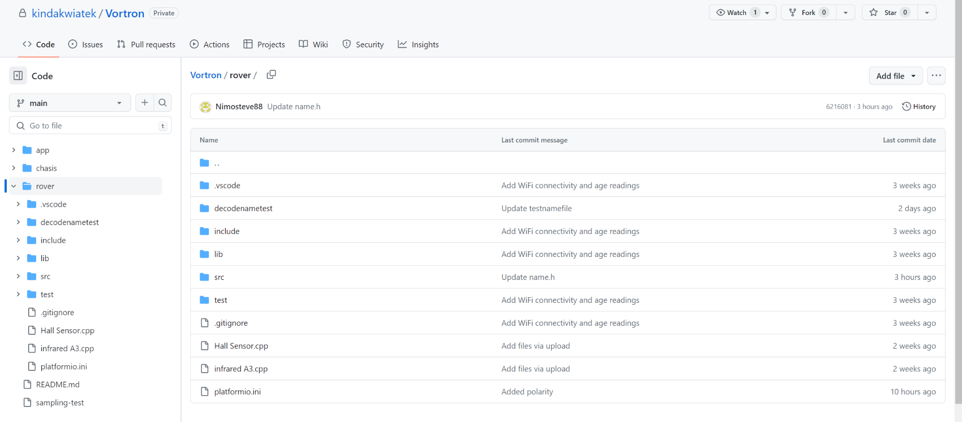

1-EEERover GitHub Repository

In terms of the communication within the team, we mainly communicated through our WhatsApp group. This was convenient to use, and every member was able to easily plan ahead on our meeting times, as well as bring up any issues or ideas that they have, when working on the project outside of the laboratory. We believe that the WhatsApp group was sufficient for our main form of communication throughout our project.

**1.1.c. Testing and Developing**

Technical experiments and design adjustments were primarily conducted in the electrical laboratory. This controlled environment offered optimal conditions for accurate measurements and precise observations. The laboratory was equipped with a comprehensive range of apparatus, all readily available for utilisation during the experimentation phase. The following equipment was provided for usage at no cost:

**Oscilloscopes:** High-performance oscilloscopes were available to capture and analyse electrical waveforms, ensuring precise measurement of voltage, current, and frequency. This was used for measuring the time between pulses of infrared radiation, which is used in comparison with the Arduino program for error corrections and the identification for possible improvements.

**Function Generators:** Versatile function generators facilitated the generation of various waveforms, enabling the simulation and testing of different electrical signals. This was used to inject test signals into analogue circuitry at the frequency of the radio signals from the aliens for determining the name. Frequency was adjusted each time for checking the filtering properties of the circuitry.

**Power Supplies:** Stable and adjustable power supplies were at hand to provide reliable electrical power for the components under investigation, ensuring consistent and controlled operating conditions. Rather than dissipating power from the battery of the rover, A 5V DC power supply was used for electrical components such as the power rails of the Op-Amp.

**Multimeters:** Accurate multimeters were accessible for measuring voltage, current, resistance, and other electrical parameters with high precision. Multimeters were also used for continuity corrections for the motor driver module in case soldering was poorly applied to the printed circuit board (PCB).

**Signal Generators:** Signal generators with adjustable frequency and amplitude allowed for the generation of specific signals required for experimental purposes, ensuring accurate testing and analysis of age and name detection.

**Prototyping Boards:** Free bread boards equipped with solderless connections provided a convenient platform for constructing and testing circuit prototypes, allowing for quick iterations and modifications, such as the envelope detector using a precision half wave rectifier and testing the output waveform coming from a test signal. Before confirming any circuit design, it was tested on breadboards to ensure reliable and accurate results and only then they were placed on the stripboard where all circuitries will be placed.

These well-maintained laboratory resources played a crucial role in facilitating rigorous experimentation and meticulous design refinements, ensuring reliable and reproducible results throughout the research process.

**1.1.d. Experimental Techniques and Methods**

Throughout the project period we usually put the new circuit components through several development stages before implementing it into the final board. Once the sensor circuit is mounted onto the board it’ll undergo:

**1. Quiescent power consumption check:**

Power supplies are connected to the circuit, and we’ll analyse the output voltage and temperature increase of the circuit to estimate the energy consumption. This will help avoid us using circuits which will discharge batteries without being active for detection.

**2. Pre-amplification signal analysis:**

The aim of the sensor is to detect the incoming signals and the response is then shown through the oscilloscope. This helps determine the type of amplification to use (comparator, inverting/non-inverting amplifier, Schmitt trigger) as well as the relative gain threshold. Noise effects are also considered and recorded for innovative ideas to improve the previous trials.

**3. Reliability estimation:**

As mentioned before, we must consider the noise signals that are also directed to the sensor and the response will then be recorded. We also had to consider taking action if the sensor’s output is too close to the original signals as this may result in imprecise or false positive detection.

**4. Signal Amplification:**

After considering the outcome of the previous sections, the signal is amplified and fed to the Arduino board to confirm the detection. This can improve the distance over which the signal can be read from and avoid stalls in the movements of the rover by getting too close to potential obstacles and also amplification may be done for readings to be easily read from the oscilloscope to interpret and use in programs.

**1.2. Design Criteria**

Within the first two weeks of the project, our group came together numerous times to establish specific specifications and requirements for our rover, which gave us a clearer understanding on the appearance and functionality of our final rover.

**1.2.a. Product Design Specifications (PDS): Customer Requirements**

After attending the workshop on Product Design Specifications, we decided to mirror the methodology of most startup companies by creating our own unique list of Product Design Specifications for our rover. While the full list is shown in the Appendix, there were 6 individual specifications that the team believed was most important and should be further justified below.

1. **Size and weight restrictions**

We expect the rover to be under 500 grams. This was planned by discussing how to change the original chassis model, including as little analogue circuitry as possible, predominantly using software for the technical functions of the rover, choosing materials that have low density but a good tensile strength and stiffness. After discussion, we decided that the dimensions of our chassis should be equal or less than the original EEEBug (Ideally, we want a size less than 124.4 x 89.7 x 3 mm for compactness and weight reduction compared to the original chassis given by the EEEdepartment). The weight was also one of the specifications that we prioritised, because we wanted to optimise the manoeuvrability of our rover around the terrain. By keeping the weight of the rover light, the motor would be able to drive a higher speed which reduces the time it takes to travel from one destination to another in the terrain.

1. **Manufacturing process/structural optimization**

The rover itself must be self-designed by our group, and due to our size and weight specifications, we decided that the structure of our rover should be 3-D printed. This would provide a reduction of the weight, in a cost-effective manner. We also decided to implement structural optimization techniques, particularly using computer-aided design (Fusion360 for our case) to help identify areas of the chassis where material can be strategically added or removed. This process ensures that the chassis is structurally efficient, minimising unnecessary weight while maintaining adequate stiffness and strength.

1. **Function reliability**

Every aspect of the rover's functionality was initially developed as a preliminary prototype, which underwent rigorous testing to identify any inaccuracies. Any attempt to aid its design was openly available to each member of the group to allow for easy peer review and discussion of possible improvements for the next meetings. At first, each specification was tested under ideal controlled environments such as a very convenient distance at which sensors can be placed to read the signals.

And then conditions were altering according to the environment where the rover will be tested during its final demonstration.

1. **Manoeuvrability and ability to cope with environment**

The rover's movement was facilitated through the utilisation of a purpose-designed joystick interface, granting complete user control, and augmenting its manoeuvrability. This intuitive implementation empowers the rover to navigate across a variety of precise directions within a coordinate plane defined by the joystick.

1. **Component Integration**

Efficient integration of various electrical components within the chassis can contribute to weight reduction. By designing the chassis to accommodate specific components, such as the breadboard, Wi-Fi shield, and microprocessor, unnecessary reinforcements or additional structures can be avoided. This integration not only saves weight but also reduces manufacturing complexity and cost.

1. **Software Implementation**

By utilising the programmable capabilities of the Arduino board, different programs were developed and uploaded to execute the required functions to determine the characteristics of the alien. This approach allowed for cost-effective and lightweight solutions in the design of the system. By replacing analogue hardware components with software programs, significant cost savings were achieved, and the overall weight of the system was reduced.

**1.2.b. Concept Generation and Selection Technique**

In each meeting, open discussions were held to facilitate idea generation and review for the design of rover functions. Each team member actively contributed ideas, which were then subjected to group-wide discussions to expand upon or provide a perspective regarding the viability of the proposed concepts. In just a few meetings each main task of the rover had a clear plan to be carried out.

**Research:** In addition to the core curriculum covered in the first year, there were supplementary concepts that necessitated independent research. Thorough investigations were undertaken to obtain exemplary code, flow charts created by team members for a clear approach, as well as comprehensive information on magnetism and the Hall probe, to ensure precise specification design.

**Problem Decomposition:** Once we reviewed the main aim of the project from an abstract point of view, we broke the aim into several smaller aims which were converted into tasks for each of us to complete (e.g., Movement Methods, Power, Signal Decoding, User Interface etc.). This offered a clear pathway for each of us to follow to assemble the complete rover.

**1.3. High Level Design**

Chassis was designed based on the original EEEbug so there is enough space for the Arduino board, a circuit bread board and sensors. Reduction in weight of the chassis improves mobility of the rover and cost effectiveness in terms of material usage. Electrolytic capacitors were not ideal to choose due to their possibility of fault caused by electrolytes. Main focuses were on:

* Control: We have aimed to make the Rover move as comfortably as possible in various environments. This means that the rover must be able to balance on an uneven terrain and in case of collisions, it must be able to return to a balanced position and function normally.
* Safe Position of Circuit Components: In order to prevent any damages to the internal structure we had to find the safest method to attach the electrical components to the chassis.
* Reduction of dimensions and weight: It’s vital for the chassis to be as light and compact as possible to avoid excessive power consumption and overheating of the motors.

**1.4. Detailed Design**

**1.4.1 Comparison with Previous Design**

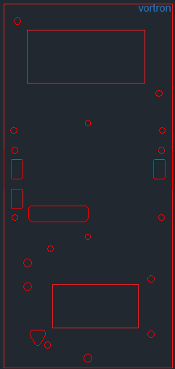Throughout the development process, the chassis underwent numerous updates and enhancements. These modifications were undertaken to look for discernible improvements and enhance the overall performance of the design. Each iteration aimed to address specific issues and refine the chassis to meet the desired objectives. Here is a 2D model of the first design that led to the final chassis:

Figure

Although it was trimmed to rid of unused space on the margins it still covers a great amount of space in the middle where the bread board will be placed. There is also some unused space near the centre that could be cleared of. There is also no modification in the centre where

the motor driver is placed.

The previous two points made were key into the next design of the chassis (below):

Large rectangular space on the right end of the chassis is now replaced with two support pillars for the breadboard to be inserted and an extra rectangular hole was added for weight optimization. The writing does not hold any importance except aesthetics so it can be removed, and the chassis can be trimmed on the sides for more weight reduction.

1b. Chassis model 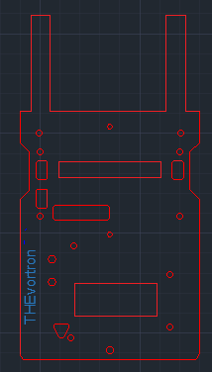2

Figure

The optimal thickness for the chassis is 3mm, as any dimension below 3mm could cause the chassis to plastically deform as it is 3D printed rather than laser cut using stronger materials in order to avoid exceeding the weight limit for the design. A thickness of above 3mm would not necessarily improve the stiffness of the chassis as not an overwhelming number of components are mounted on the board,

thus it would only add unnecessary mass.

Extrude commands in AUTOCAD transformed the 2D design into a 3D format which gives a good view on the placement of components and their respective spacings. Below is one illustration of such command in use:

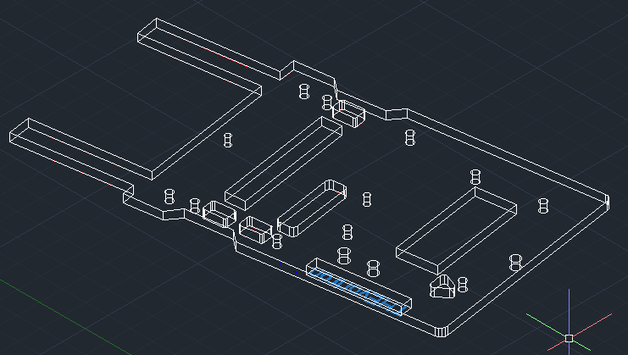

4-Chassis Design

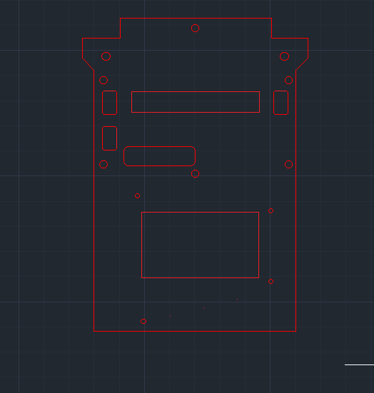

Figure

3D version of the chassis with Name replaced by a rectangular empty space for weight optimisation.

Also, the scaling is slightly smaller compared to the original EEEbug chassis for size reduction.

The dimensions of this model are 124.4 x 89.7 x 3 mm. However, the design is not compact. A rover must be smaller in length and its mass evenly distributed. Also, the components are too spaced out when the prototype was printed so this leads to the following finalised design:

The pins for the components were translated downwards to be closer together and any empty space generated at the top was proportionately cut and reshaped to give a smaller and compact design. Also, the position of the other screw holes was changed so that the components lie as close to each other to save space and improve aesthetics. The breadboard will now be replaced by a strip board to reduce weight and to improve clarity of circuit schematic and by using a support created in Fusion 360, we can mount the stripboard on top of the Metro and Wi-Fi-shield such as: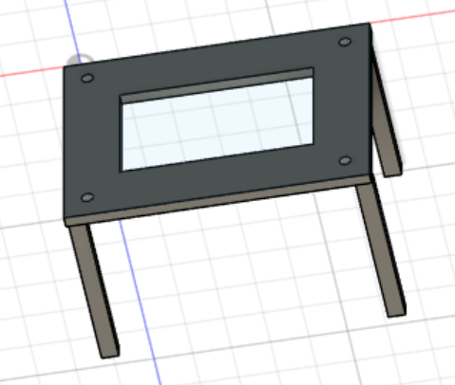

Figure

This precautionary measure is implemented to mitigate the potential risks associated with collisions involving nearby surroundings or other rovers present within the arena. By employing this approach, the vital components are safeguarded against potential impact and subsequent damage. Moreover, it minimises the possibility of circuit parts on the breadboard being displaced or misaligned.

Additionally, this design choice facilitates the adaptation of the chassis to a more compact form, enabling it to occupy a reduced amount of space within the arena. This resizing capability not only enhances the overall manoeuvrability and control of the rover but also facilitates easier handling, management and could also make transportation and packaging more feasible.

In terms of the design of the wheels, the wheels given in the initial lab box do not have a good grip on surfaces and they are not optimised for weight and pressure tolerance so Computer aided software such as Fusion 360 and careful consideration to alternatives such as buying a well-designed wheel online were made. However, we have seen many contenders ordering wheels on online platforms such as amazon and models we were considering were already taken by them, so to allow for distinctive alternatives, we plan on remaining with our own design for the rim.

All dimensions were chosen in millimetres. The first attempt for creating the wheel is shown in the following picture (on next page):

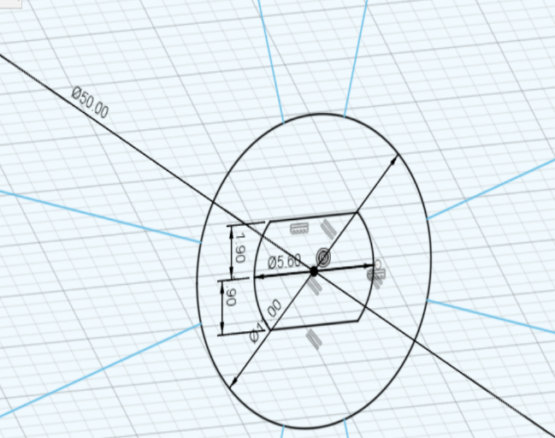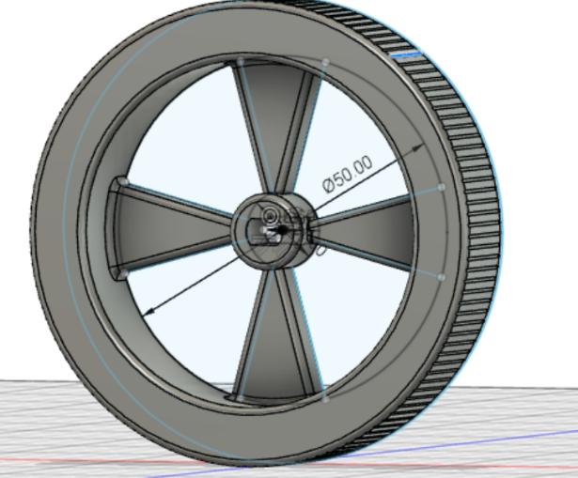

7-3D Model of Wheel(s) Dimension sketch of the structure

3D model on the left and cross section of inner components on the right. This design was made to be compatible with the motor given in the lab box. Although rubber bands may not be used in this trial due to the outer pattern for grip on the surfaces to reduce added mass from the rubber bands, the problem is that this pattern may not be the better alternative to rubber bands because less friction of the rim to surfaces could mean chances of skidding and losing control of movement of the rover. Furthermore, the aesthetic design was omitted making the rim look as a rough attempt.

A different approach was taken after some research was done into using more advanced settings on Fusion 360: Shape optimisation. This setting allows for software to apply a test pressure onto a section of the wheel and lets the user choose a balanced ratio between mass reduction and mass needed for pressure resistance. A 3D structure is then shown that can be traced and modified to our preferences. The next contender for the rover’s wheel is shown below:

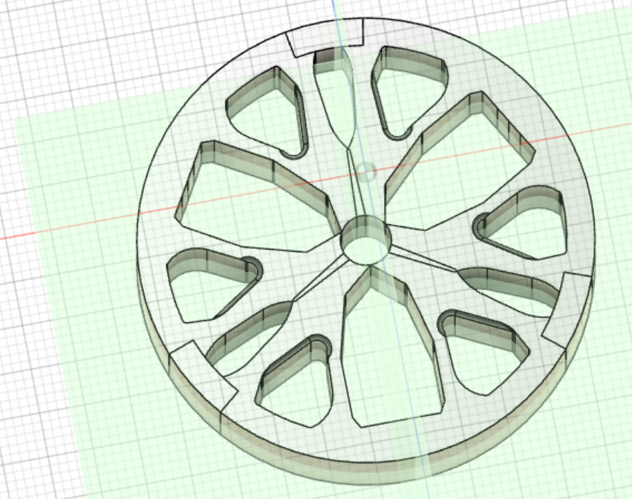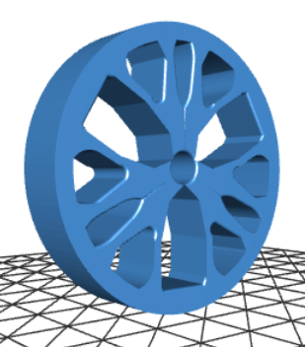

Figure Figure 9

On Figure 8, planes of symmetry are used to ensure the wheel is symmetrical.

Width of this design has increased to improve stability on surfaces and rubber bands will be attached revolving around for improved grip on surfaces.

However, since we only use 2 motors to reduce weight, rather than having 4 wheels which can add more mass to the rover, a better choice would be to add a third stabiliser wheel in front for balance. This design is based on the traditional “caster wheel” model. We can see on the right-hand side, in

the picture below that even with a dense material such as steel (about 8000 kilograms per metre cubed), the mass of the caster wheel is only 25.444 grams, thus it will be much lighter if we use a resistant type of plastic suitable for 3D printing such as Polylactic Acid (PLA).The design could be optimised by modelling the wheel with holes or any other spacing to reduce mass

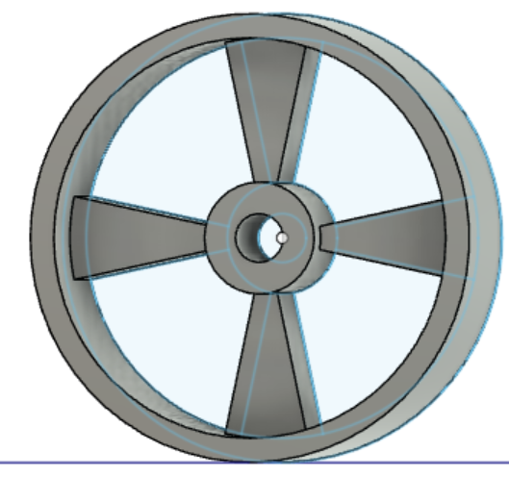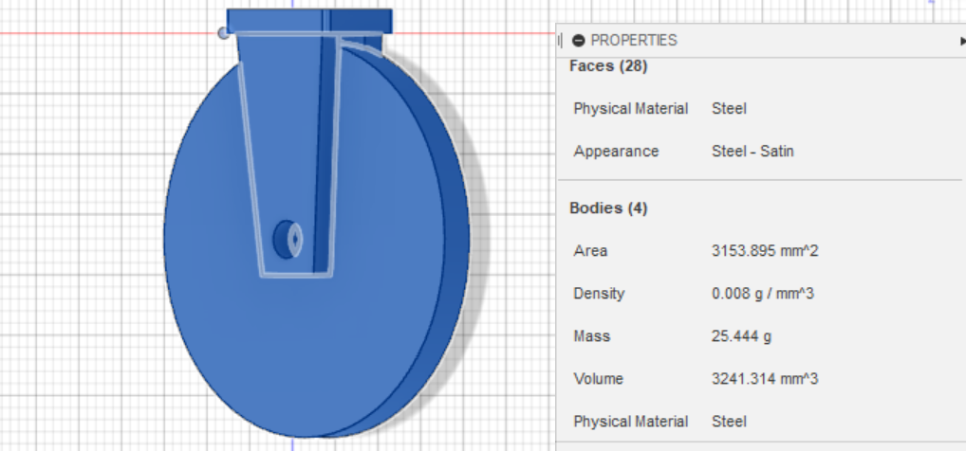

Figure Figure

In this initial attempt, the caster wheel was not optimised for weight reduction, so the left hand picture above shows the modified version based on the previous designs shown for the motor wheels.

Although no resistive patterns were placed on the wheels because the purpose of a third is to balance the rover for control, so a frictionless wheel will aid the rover to move at its high speed. When 3D printing the components there were error margins due to printer inaccuracy. which lead to components not being able to fit into motors and other places on the rover. Many attempts to readjust the size of screw holes and other parts had to be taken which are not included in the report due to repetitiveness, but we will show an example on how testing was done in the following pictures:

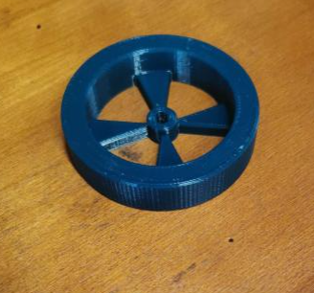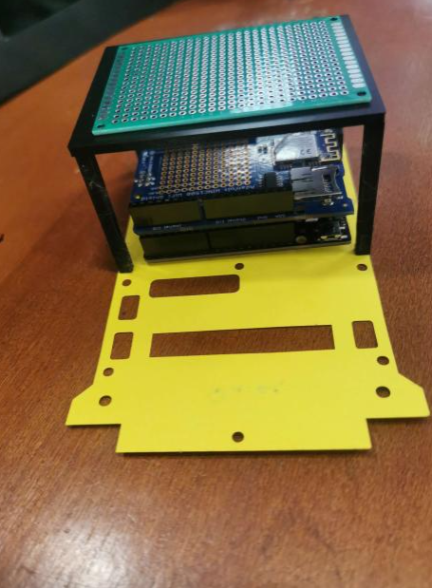

We have asked the technician to first design 2D attempts to test any irregularity and margins of error, since a full 3D model could result in a waste of resources, just like it unfortunately did with our first wheel design. In this case, we have checked if the screw holes match the Metro board’s and if the support for the strip board can be successfully mounted on top of the Metro board. In this case, after many trials it successfully matches our ideal design. However, with the first trial of the wheel, the motor’s pin does not match the socket of this design, so it had to be readjusted for a next, hopefully improved version. Doing this testing well ahead of the time made us in a good position to finish the rover ahead of the deadline so that we can further improve our final design and also prepare for the final demonstration of the completed design.

12- Idea of Assembly for Rover

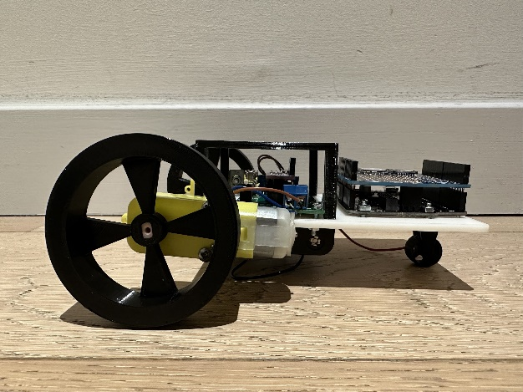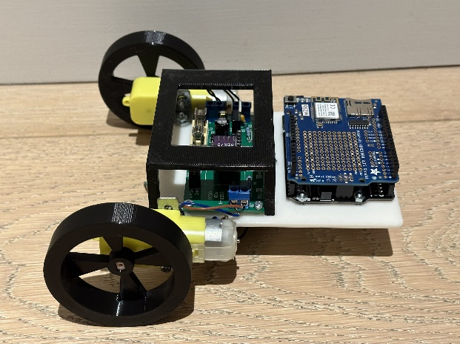

Figure 13

**1.5. Budget Management**

**1.5.a. Budget Efficiency**

The assigned budget for additional equipment is £60. Throughout the project the ones who’ll be making the orders are those focusing on Circuit design due to their needs for several circuit and motor components. Several criteria were considered before buying a certain component to improve the cost efficiency of the project. Components were also given free by the EEE department, so our budget could be also used on specific components to aid with the quality of the rover’s performance.

These include:

* Considering the different hardware options available.
* Looking at and comparing different technical datasheets to ensure that the components perform to the best of its ability.
* Replacing hardware with software where possible

This process proved to be very efficient in terms of avoiding technical issues. It’s also proved to be helpful and cost efficient as it prevented us from buying existing circuit components.

**1.5.b. Expenditure Table:**

Departmental Components:

|  |  |  |
| --- | --- | --- |
| Part | Quantity | Cost each/£ |
| ADAFruit Metro M0 | 1 | 25.0 |
| SFH300-3/4 phototransistor | 1 | 0.66 |
| AdaFruit WINC1500 Shield | 1 | 34.0 |
| H-Bridge motor | 1 | 7.49 |
| Subtotal | | 67.15 |

Additional Components:

|  |  |  |  |  |
| --- | --- | --- | --- | --- |
| Component | Manufacturer | Model Number | Quantity | Price each [£] |
| Hall effect sensor  (Not used in final rover) | HoneyWell | SS441R | 1 | 2.51 |
| Hall effect sensor | QST | QMC5883L | 1 | 3.90 |
| Positive to Negative Converter | EEE department | ICL76605CPA | 1 | 1.74 |
| Strip board | EEE department | MEDIUM 95mm X 127mm | 1 | 1.44 |
| Subtotal (all components) | | | | 9.59 |
| Subtotal (rover components) | | | | 7.08 |

|  |  |
| --- | --- |
| Departmental Components: | 67.15 |
| Additional Components:  (Effective Cost) | 7.08 |
| Total Cost: | 74.23 |

The cost for additional components for our rover is well below £60 so it is cost efficient.

**Part 2: Technical Design and Progress**

**2.1. Sensor Design: Circuit diagrams and functionality**

**2.1.a Infrared Sensor**

For our infrared sensor we have used a phototransistor. A phototransistor is a type of semiconductor device that can be used as an infrared sensor. It operates on the principle of the photoelectric effect, where incident light causes the generation of electron-hole pairs in a semiconductor material.

When infrared light falls on the base-emitter junction of a phototransistor, it excites electrons from the valence band to the conduction band, creating electron-hole pairs. These electron-hole pairs modify the conductivity of the semiconductor material, allowing the phototransistor to detect the presence and intensity of infrared light.

The base-emitter junction of the phototransistor acts as a photodiode. In its normal operation, without incident light, the junction is reverse biased and only a small leakage current flow. However, when infrared light is present, the electron-hole pairs generated in the base region reduce the effective width of the depletion region, allowing more current to flow. Connect the circuit as shown in the figure, powered by a 5V voltage supply:

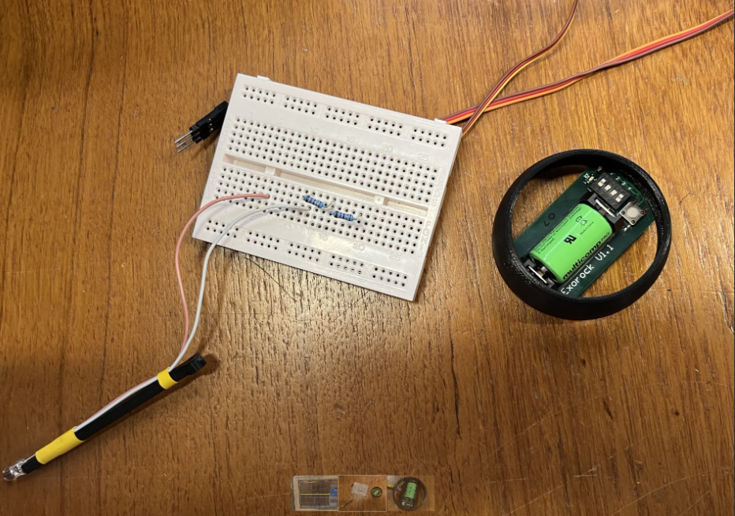

Figure

We planned to use the original infra-red sensor to reduce the cost and put it directly under the infra-red emitter (test source). The signal can then be detected by the sensor. However, the amplitude of the signal drops rapidly with distance and for longer distances no signal is detected. Rover is designed to travel close enough to the alien but this could waste the time efficiency of collecting information on all the aliens so amplification may be needed.

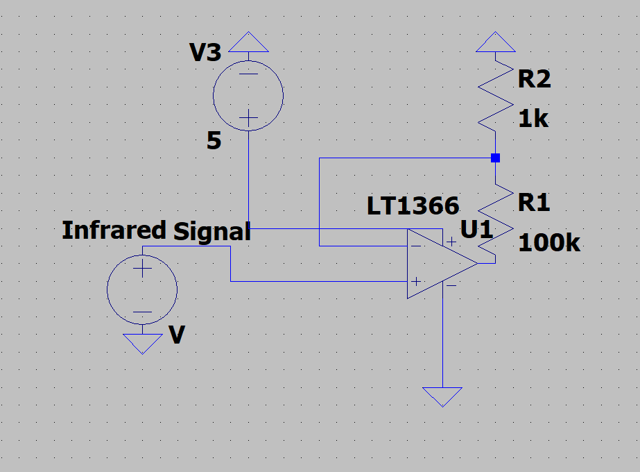

Figure

A simple non-inverting amplifier could be used to increase the amplitude of the signal so that it can be detected from further distances. As explained, taking the reading of a different voltage from the pulse is not a problem for our rover design because the program for detecting the age in Arduino takes average voltage readings and calculates the threshold based on this average, and the time between pulses is detected between two consecutive rising edge pulses. However, ambient light as noise may interfere with the results so the photosensor must be covered in a foil or further programming may be done after the report to take this into account.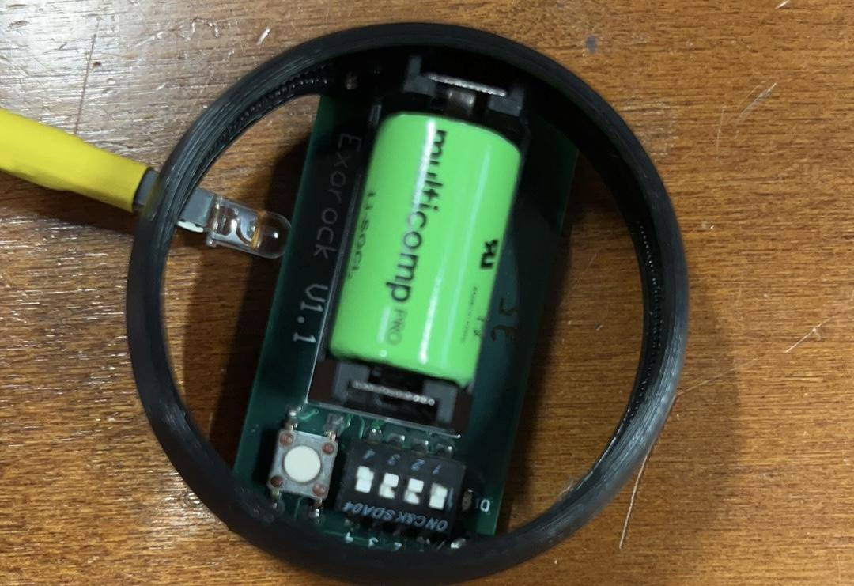

Figure

As long as the circuit is connected correctly, pulses can be observed on the oscilloscope.

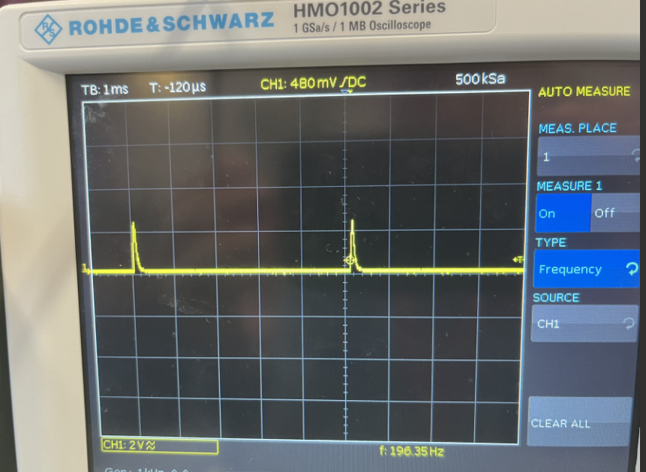

**1.b Magnetometer**

In a Hall probe, the conductor is typically a thin strip with a rectangular or diamond shape, and the current flows along its length. When a magnetic field is applied perpendicular to the strip's surface, the Lorentz force causes a potential difference, known as the Hall voltage, to develop across the width of the strip. By measuring the Hall voltage, the direction of the magnetic field can be determined.

In this project we initially used the SS441R Hall effect sensor, but this was deemed insufficient for the task at hand as it did not allow for distinguishing between the 3 possible states: N up, N down and neutral.

This sensor was replaced with a FXOS8700 3-axis accelerometer and magnetometer. This a highly accurate sensor and was used in tests which confirmed that the code used for determining polarity works correctly.

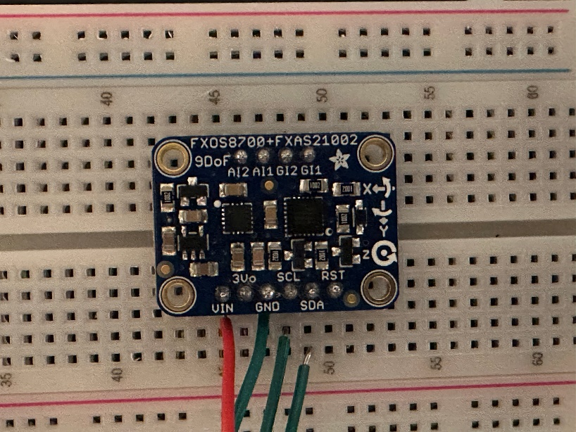

Figure

Due to budget constraints in the final rover the FXOS8700 sensor will be replaced with a cheaper QMC5883L. The new sensor is also a 3-axis magnetometer and uses an I2C protocol to communicate with the MCU. This change requires minimal code changes and no changes to the algorithm.

**1.c Radio Sensor**

To get the name of the alien, we need to first recognise that there`s two stages to this, an analogue stage, and a digital stage.

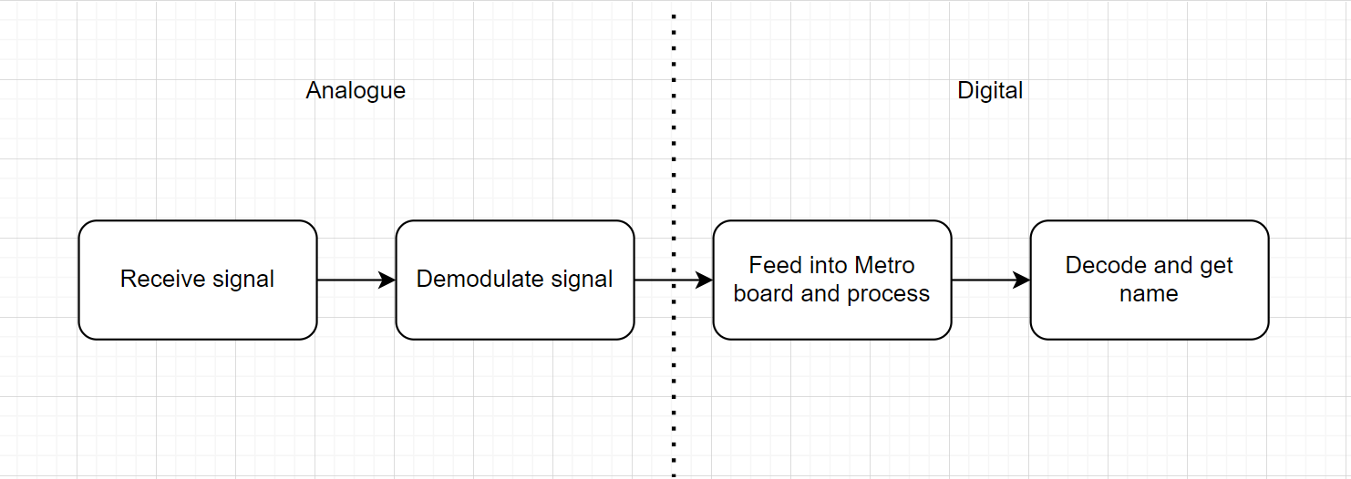

Figure

The digital stage is explored later in the report since it involves decoding the UART signal, we first need to receive our signal and demodulate it to the original UART signal. To receive the signal, we need an antenna, and it needs to be rectified. Then we need a capacitor-resistor pair in parallel to trace the peaks.

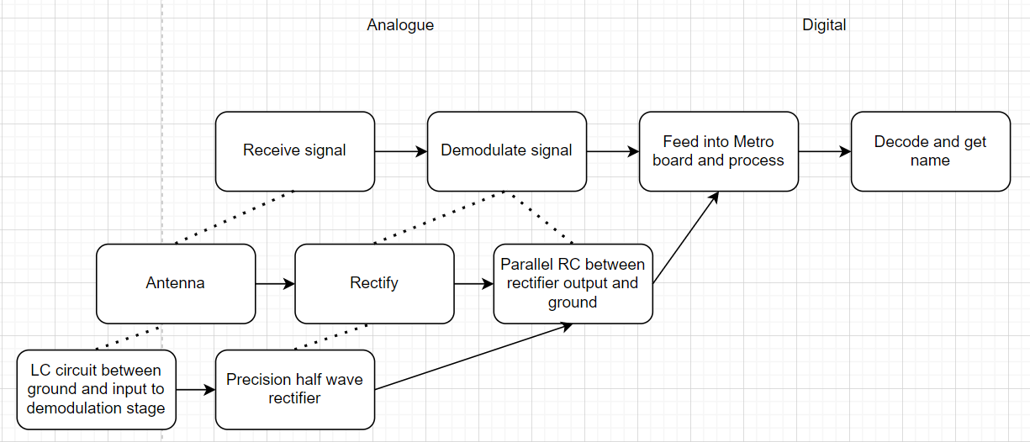

Figure

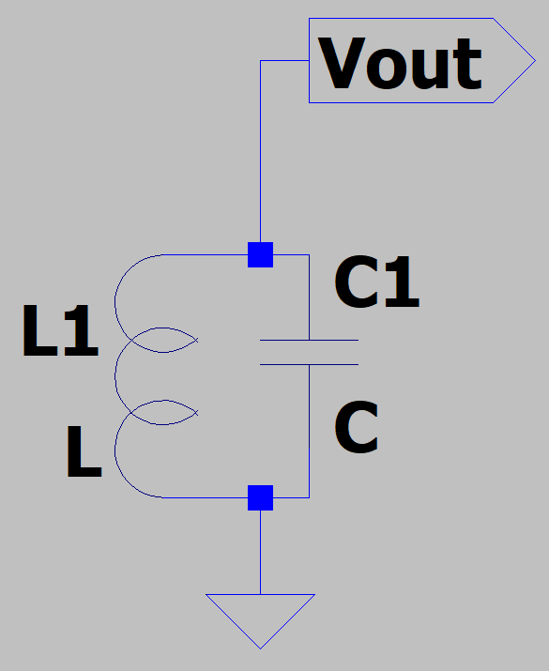The antenna can be made by an inductor and capacitor, as shown on Figure 20, so I prioritised it for later. The major task was rectifying the signal. We cannot use a standard diode due to the 0.7V drop across it, meaning the signal must have an amplitude greater than 0.7V. We can eliminate this problem by using a precision half wave rectifier.

Figure

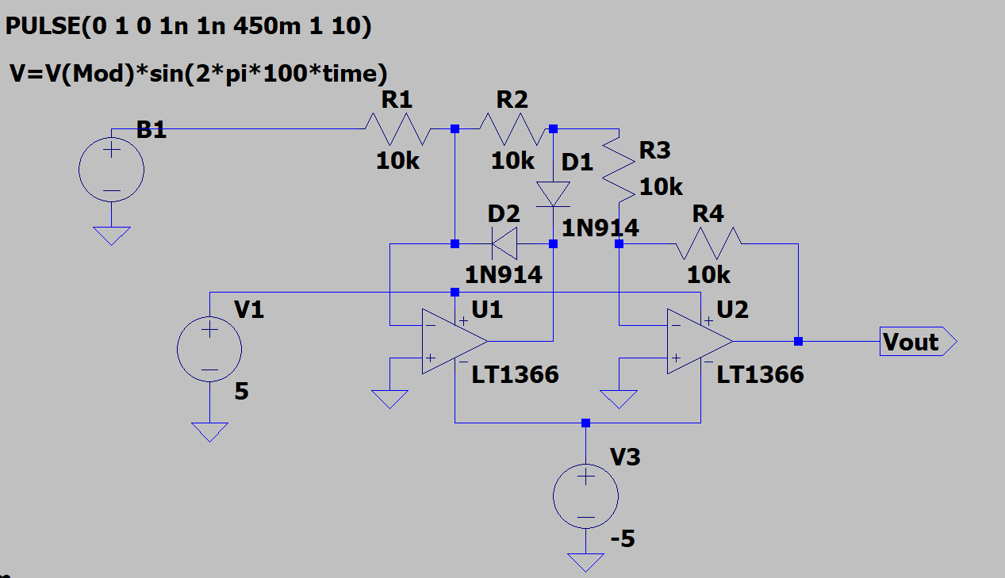

Figure

On Figure 21, we have an example of a precision half wave rectifier, which was shown to us during our ADC autumn term. The issue is it uses two opamps, four resistors and two diodes. Surely, there must be a simpler rectifier that uses less space.

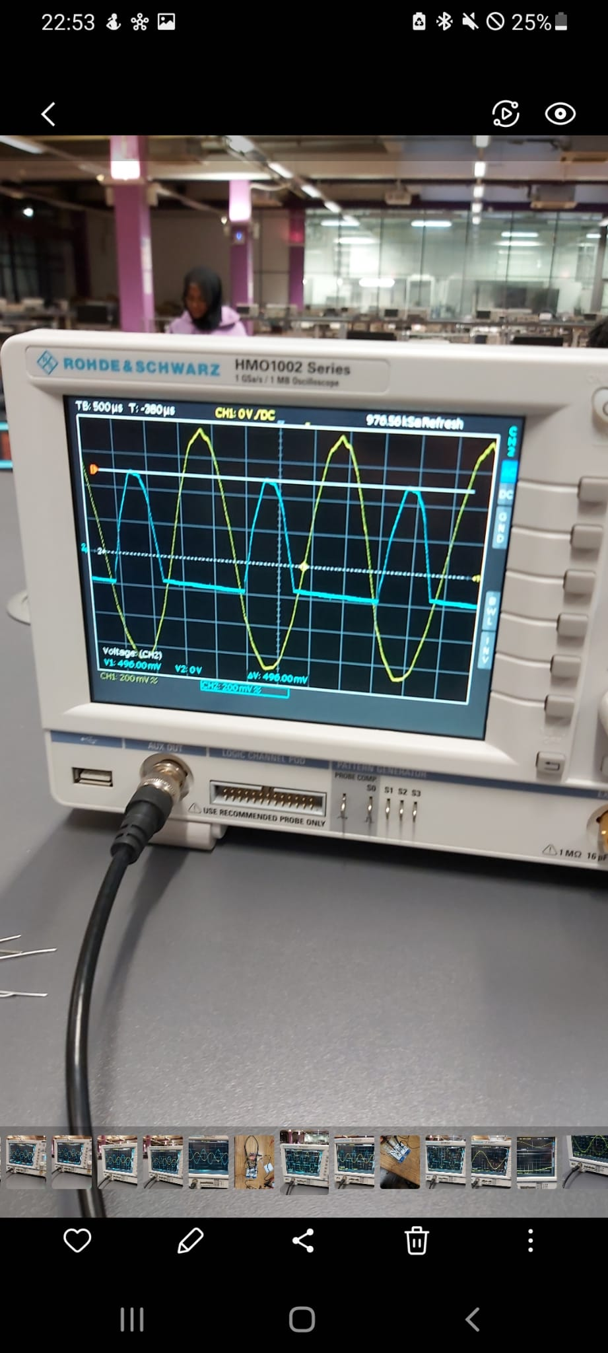

Figure

What about a single supply opamp? It clearly rectified my input signal when I tried to amplify it, as shown in Figure 9, back in autumn`s ADC lab, see Figure 22 for circuit. This would also save space since we would be able to amplify our signal and rectify it in one stage, as opposed to two opamp stages.

The issue is the opamp didn't fully rectify the signal since a negative portion of the input reached the output. This clearly isn't an offset since the probe is set to AC, therefore this circuit wouldn`t function as intended.

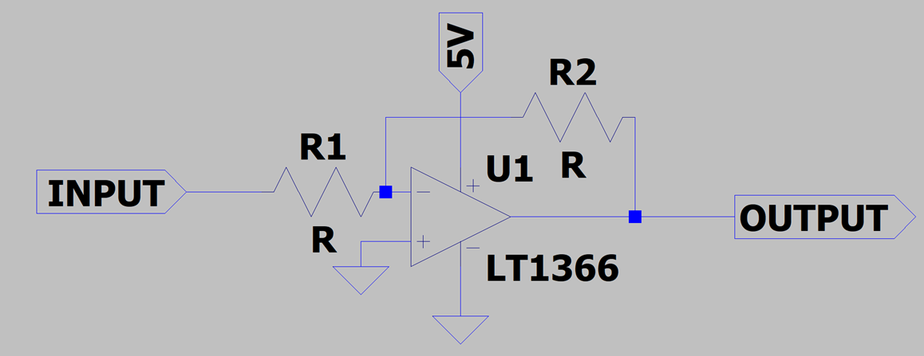

Figure

Figure

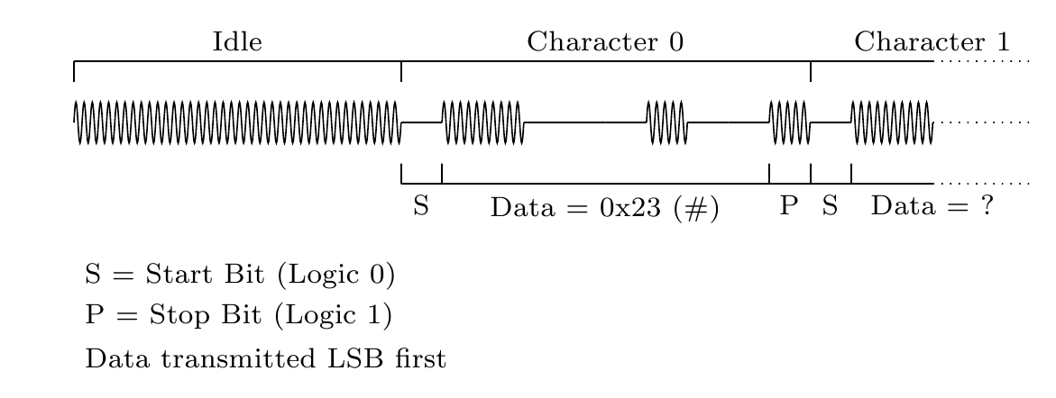

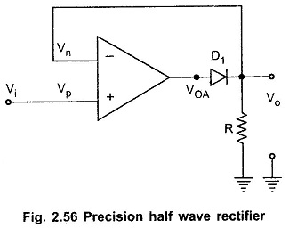When it comes to amplifying our signal, it doesn't matter whether our amplifier was inverting or non-inverting, our amplified signal would be the exact same, when comparing both types of amplifiers with the same gain, since the input signal is horizontally symmetric, as seen in Figure 24.

Then I started to research for a simpler, but proper, precision half wave rectifier. To save time, I looked at google images since it would recommend images of precision half wave rectifiers from various articles. I came across a simple rectifier, Figure 25, from EEEGUIDE.COM.

Figure

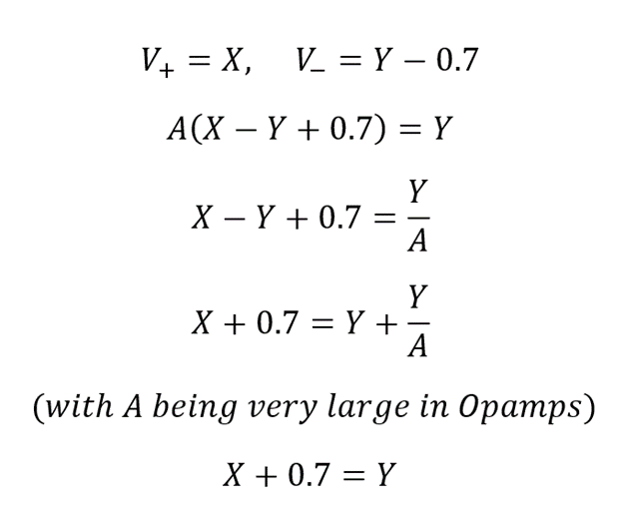

Figure

Opamps are designed to act as differential amplifiers. $V_{out}= A(V_{+}-V_{-})$, where A is the

gain of the opamp(usually very large).

We can mathematically prove that this rectifier eliminates the issue of the 0.7V drop across the

diode, see Figure 26.

There was only one issue, I didn't have access to

-5V. However, there was a positive to negative converter IC available in the EEED store, so I ordered it. Here another problem arose. The pins of the IC were too short to fit into the breadboard, so I had to compromise by using a small piece of stripboard and soldering the required circuit from the datasheet, Figure 27, (Renesas) of the IC on it to make it easier to use.

Figure - circuit from datasheet(left} and assembled circuit(right)

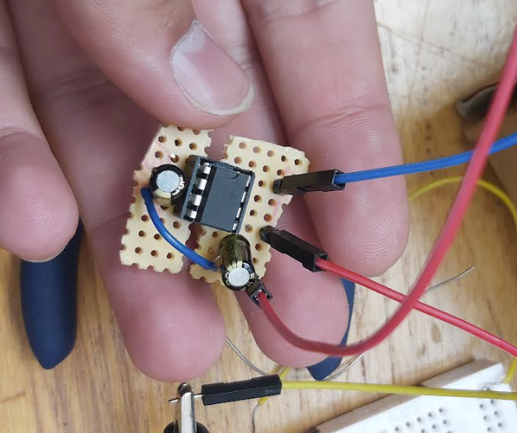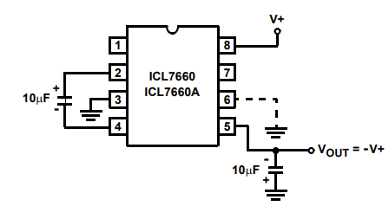

Now, we can test the precision half wave rectifier.

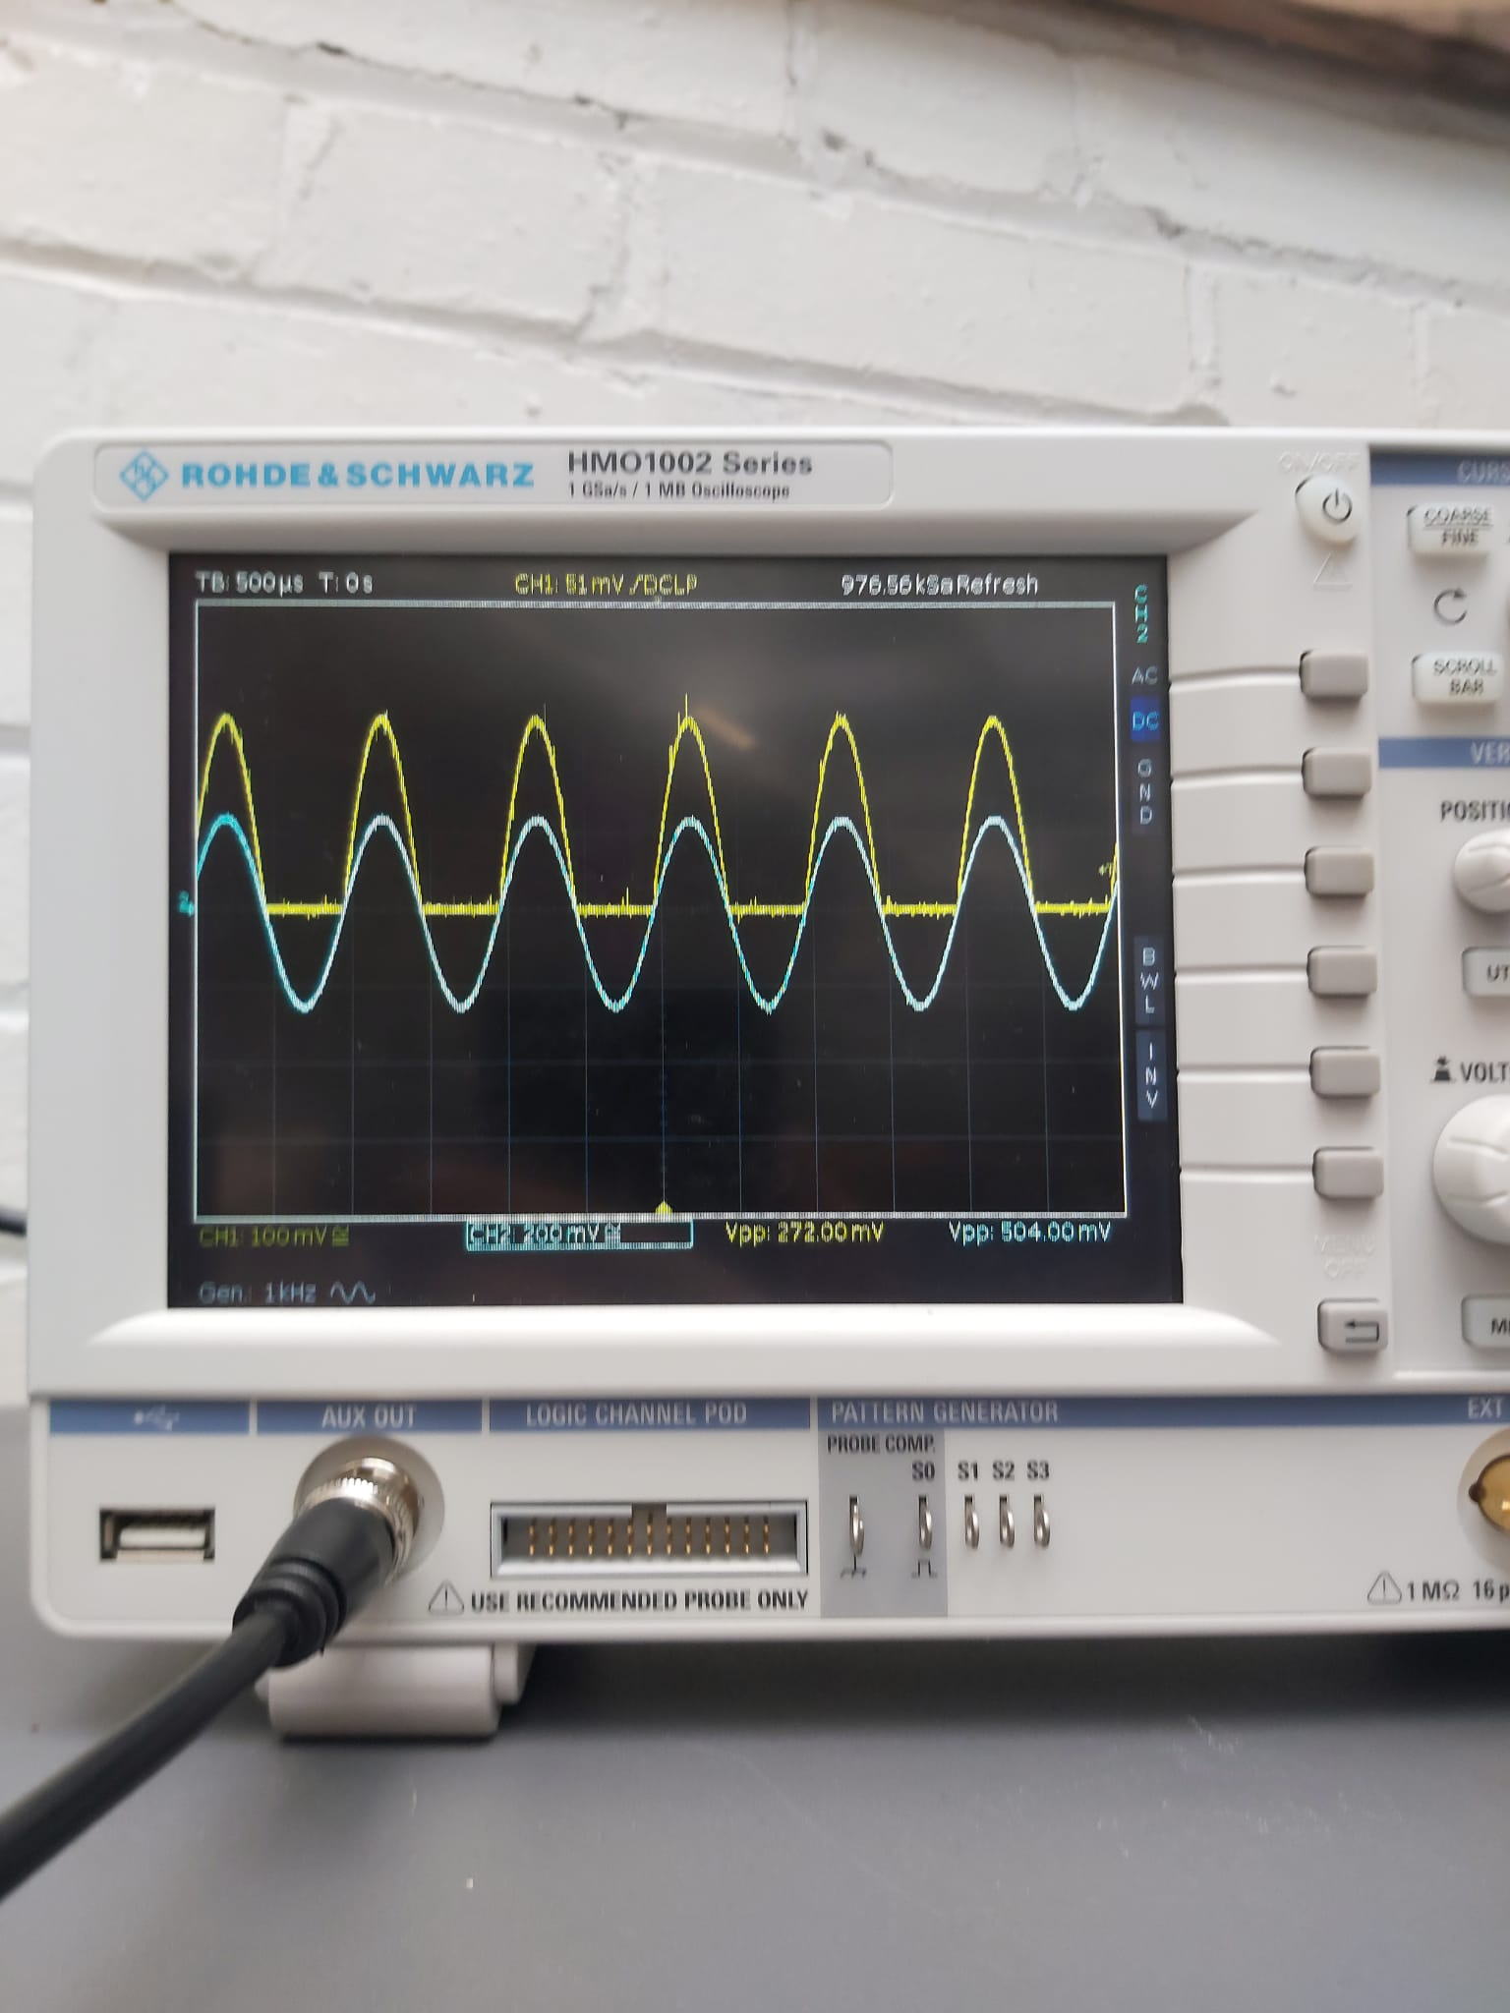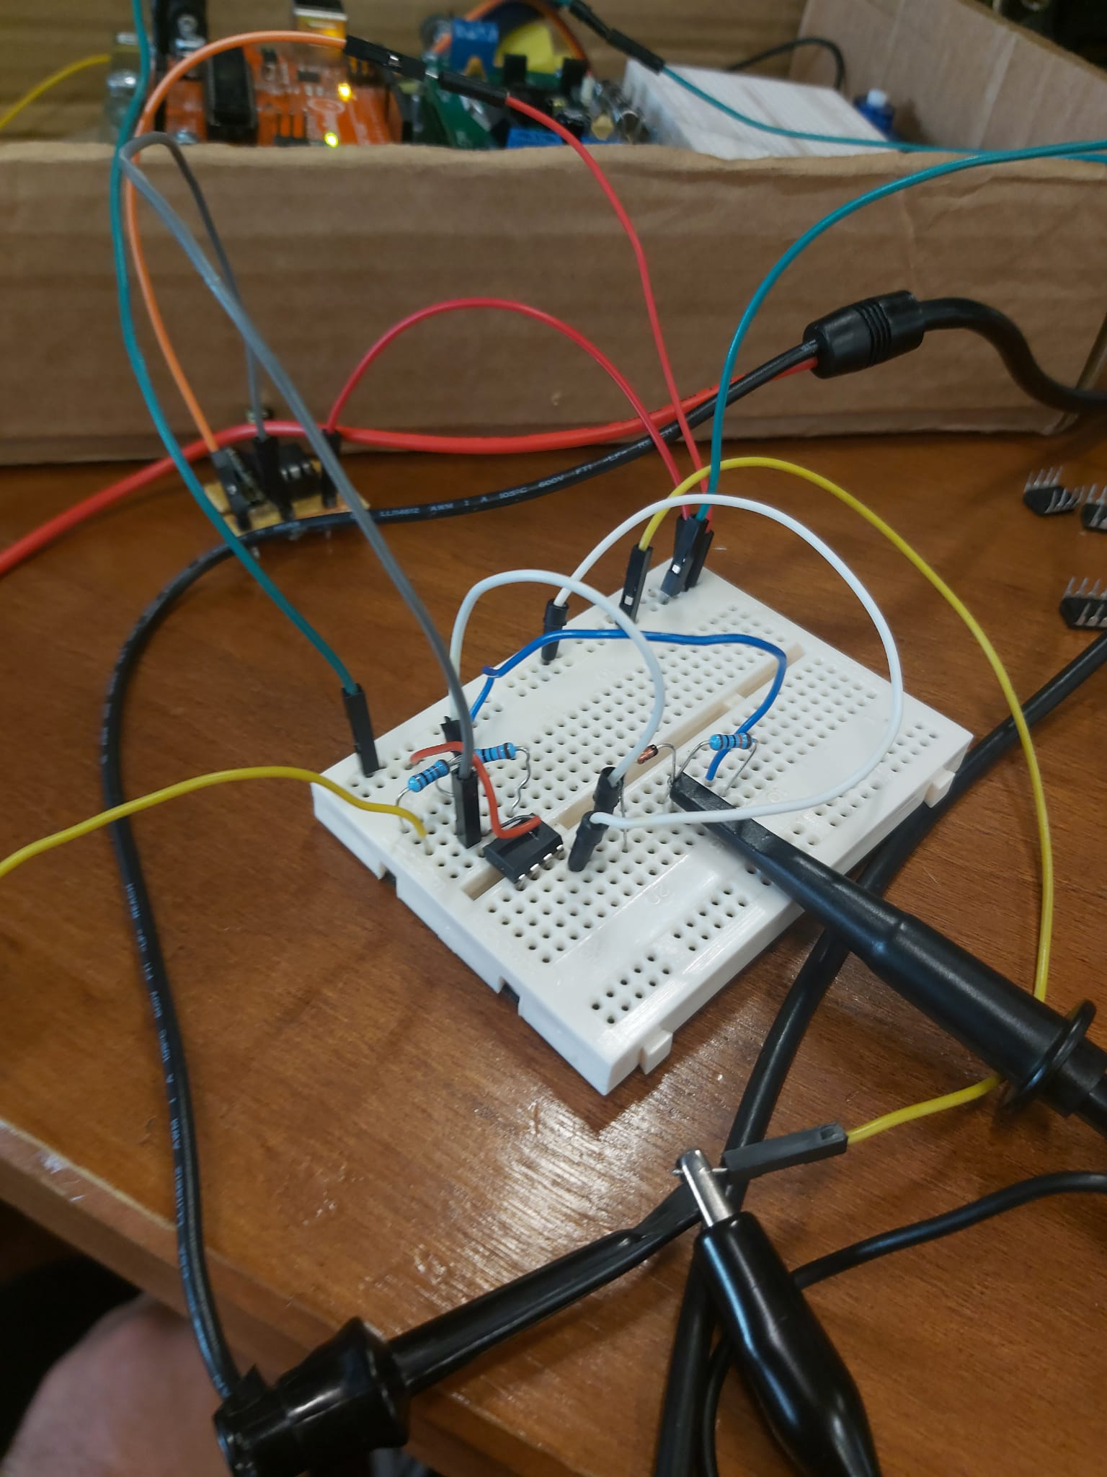

Figure

Not only does the rectifier work, but it amplifies the signal by a little. The amplitude of the output is greater than the amplitude of the input. (272mV > 252mV)

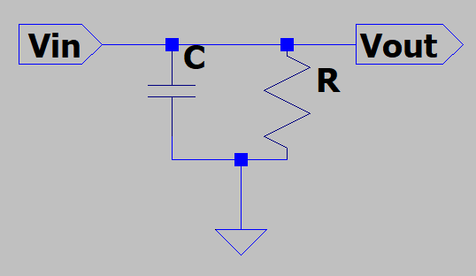Next, we need to trace the peaks. This can be achieved by a capacitor and resistor circuit shown on Figure 29.

Figure

The main feature of this circuit we consider is the time constant, 𝝉. $τ = RC$. We first need to choose our time constant before we can choose our resistor and capacitor. An article (Rutgers university) suggests than $T_{c}<τ <T_{m}$

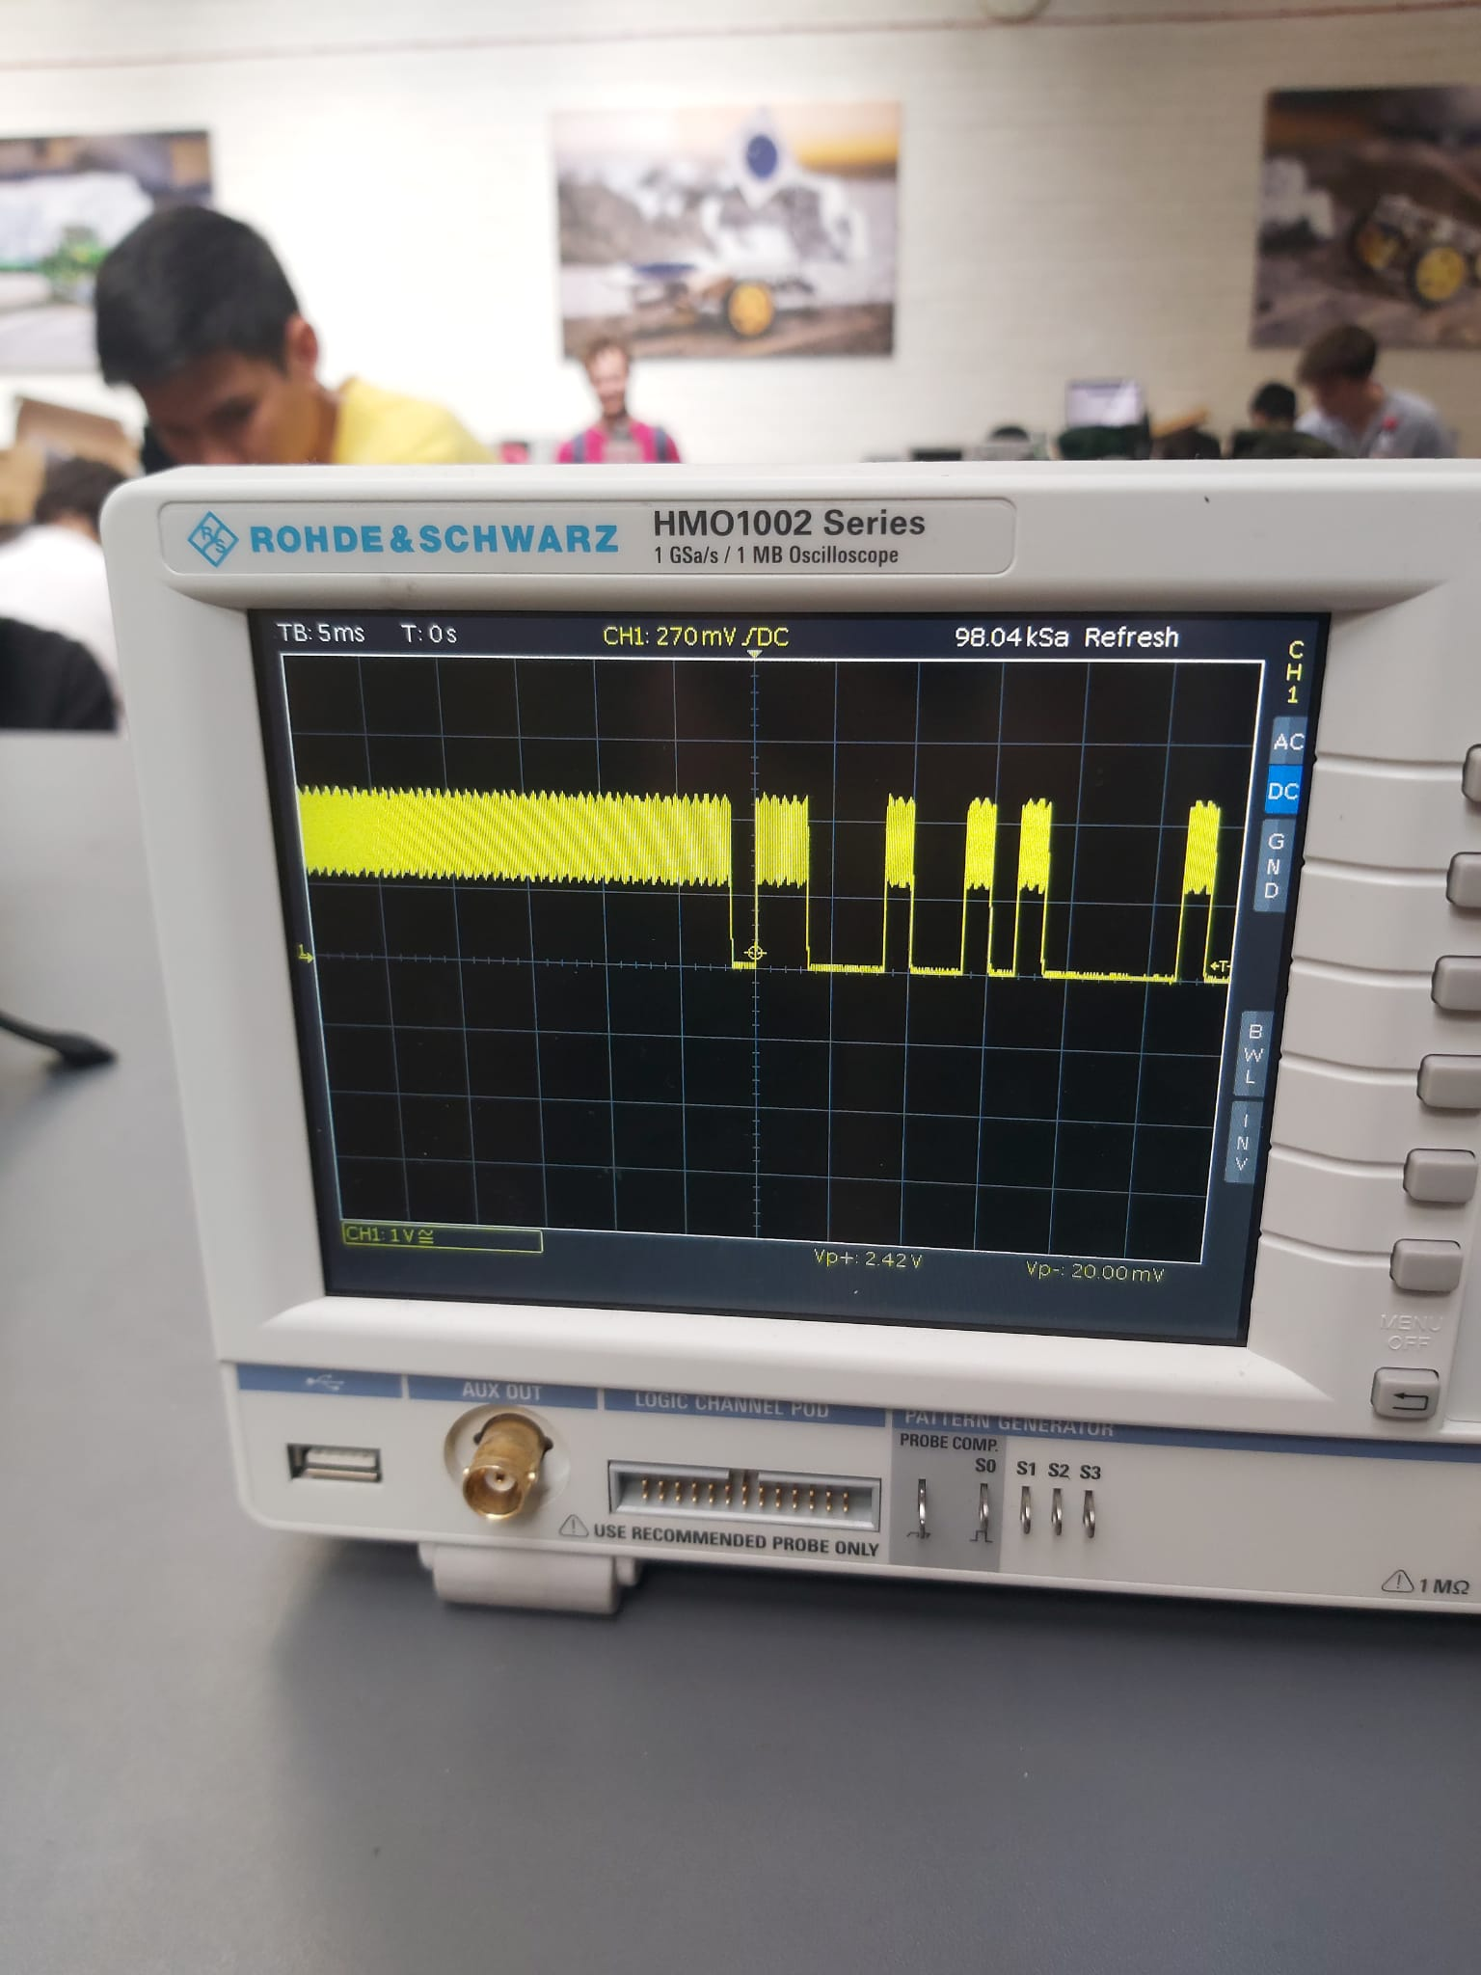With a carrier frequency of 61kHz and a modulating frequency of 600Hz, $T_{c}and T_{m}$ is $16.4μs and 1.67ms$ respectively, accurate to three significant figures. I chose a 900Ω resistor and a 22nF capacitor, giving me a time constant of $19.8μs$. When testing the circuit, it clearly created a ripple at the peak of the input signal of the alien, and discharged when the pulse was at its minimum, which is 0V,as shown in Figure 30. Next, we need to smooth out the signal by passing it through a low pass filter.

Figure

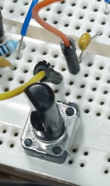

Figure

Since we haven’t gone into detail about the corner frequency of the low pass filter in envelope detectors, I decided to choose a capacitor and use a potentiometer, see Figure 31, to vary the corner frequency until the ripples decreased.

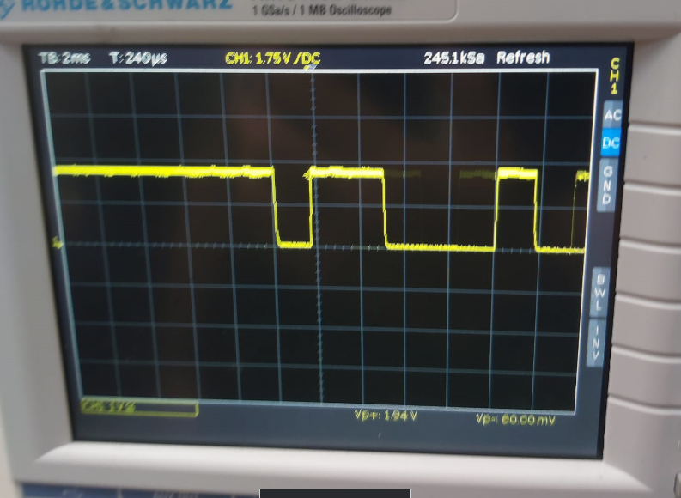The resulting capacitance and resistance were 33nF and $1.5kΩ.$ That gives us a corner frequency of around 3125Hz. We filtered out the carrier signal, whilst maintaining the modulating signal. However, there’s one more stage to this. The signal isn’t completely flat at the peak. It oscillates a bit around 1.94V.

Figure

To solve this, we use a comparator.

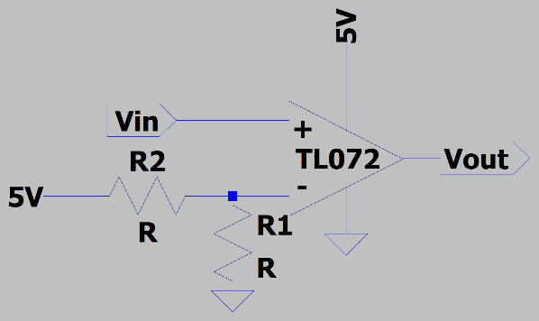The opamp produces a pulse wave ,solely relying on when $V_{in}>V_{-}$. If the inequality is true, $V_{out}=V_{cc+}=5V$ as long as it’s true. If not, $V_{out}=V_{cc-}=0V$.This gives us our pulse wave, which we then feed into the metroboard.

Figure

Before we can do that, we must test our circuit. With the complete circuit, the signal has been successfully demodulated. However, it has an offset. Setting the probe to AC didn`t help since that shifted the whole wave below 0V. As a consequence of this, we need to implement a potential divider at the output of the comparator since the input pin on the metroboard is 3.3V.

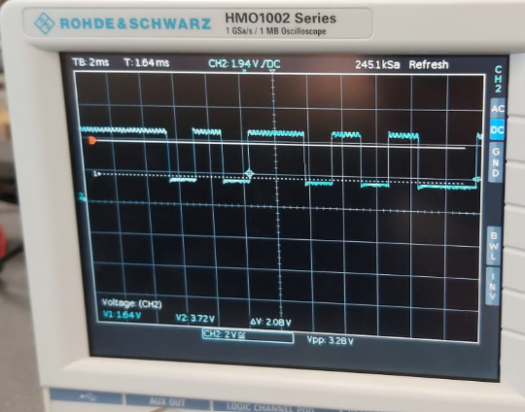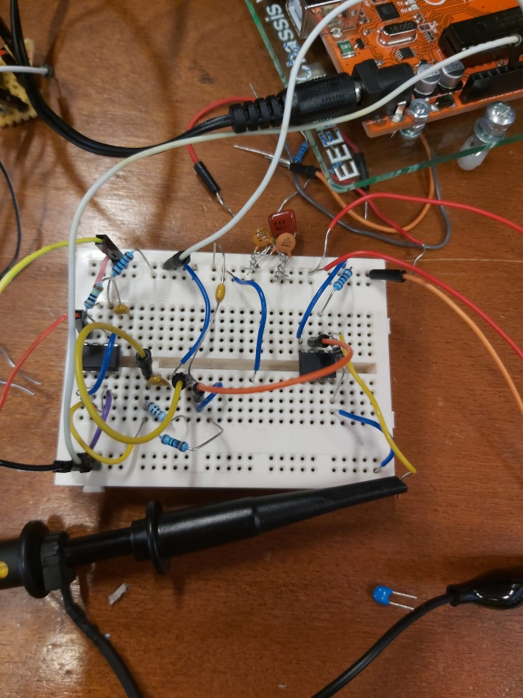

Figure

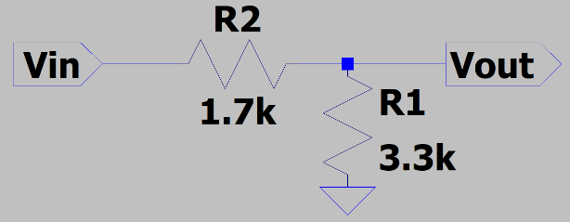

With all the heavy circuitry done, now we can focus on the antenna. We could either make our own coil,our inductor in principle, or use a normal inductor. We tested both below.

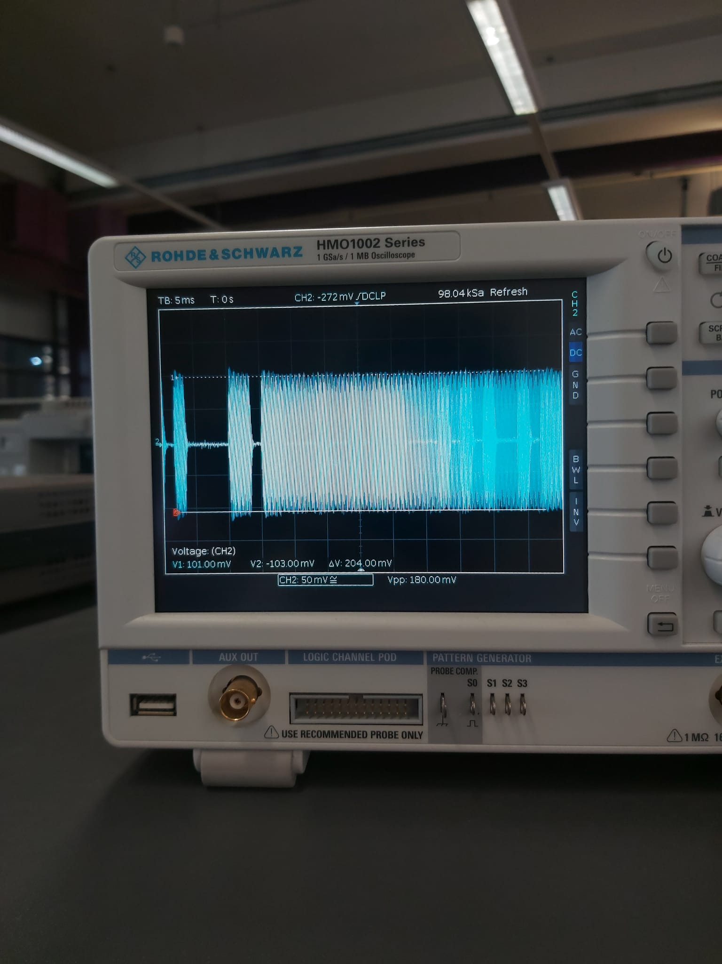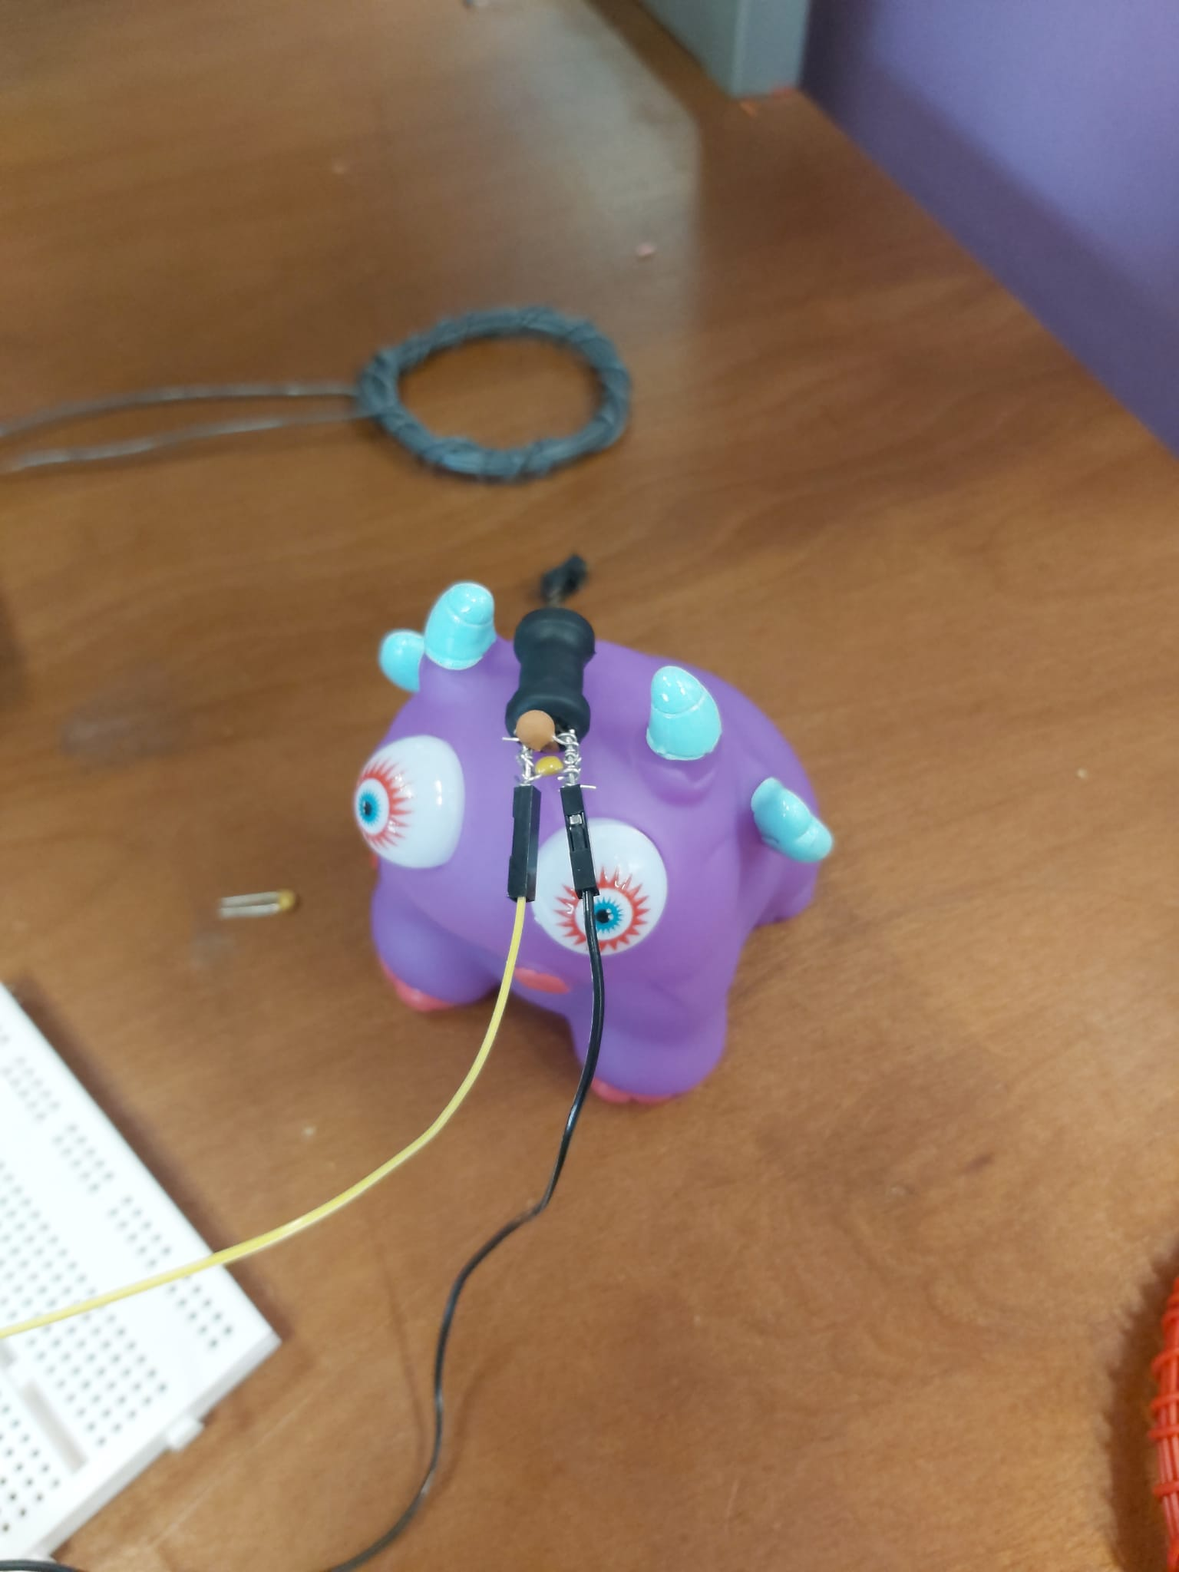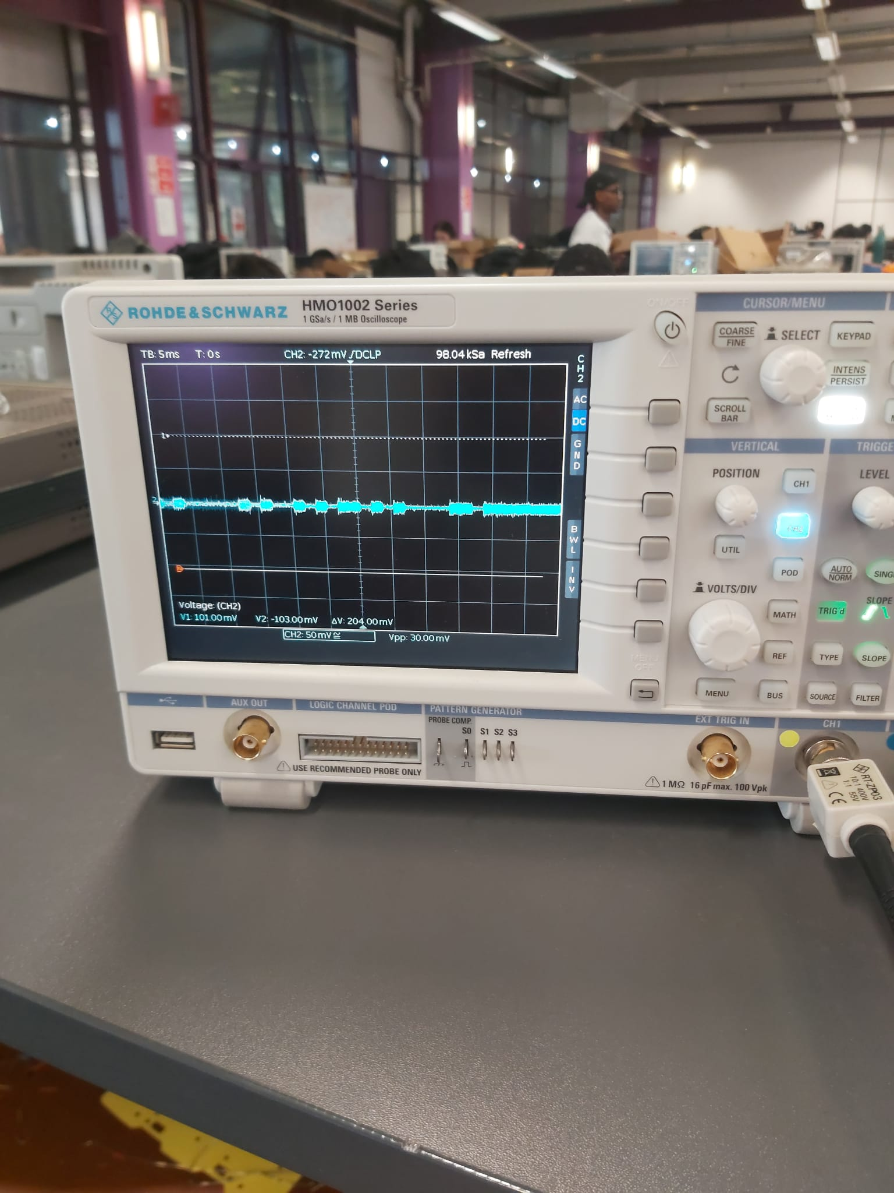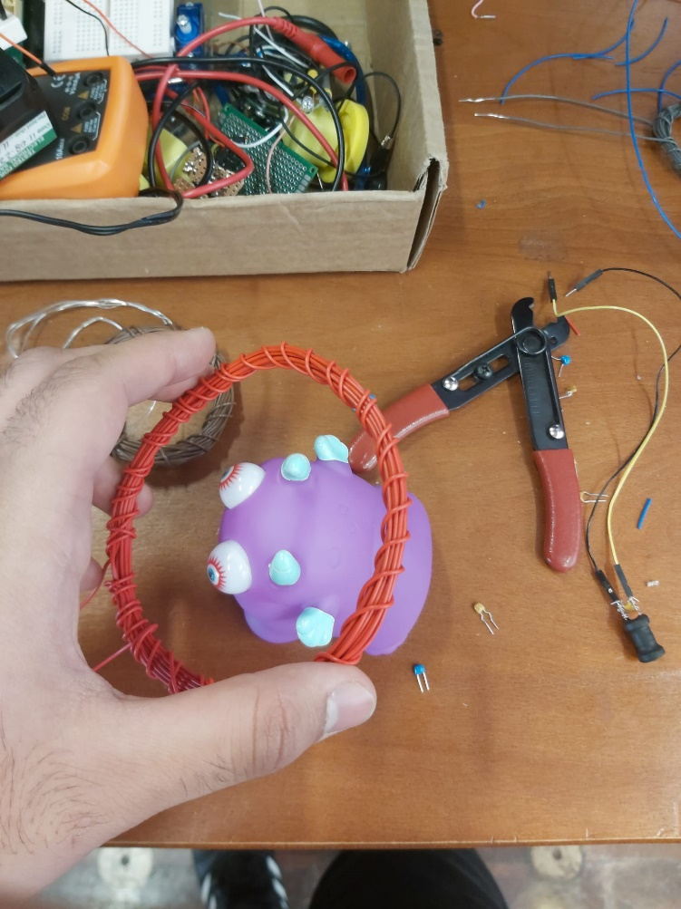

The inductor and capacitor clear outperform the coil and capacitor so we used the inductor and capacitor as the antenna.

**2.2. Motion: Motors**

For the selection of the wheel design, we initially explored many options and did extensive research on mecanum and omnidirectional wheel designs. However, a conclusion was established as a team that those designs were not suitable. This is because firstly, the weight of the 4 wheels and motors combined would add a significant amount of weight to the rover, which did not meet the PDS on the optimization of weight. Secondly, the terrain where the rover will operate in is relatively rough and uneven, which is not well-suited for mecanum wheels. This is because there will be a lack of traction on the small angular rollers of the mecanum wheels, causing it to lose stability and control. There are also other disadvantages such as limited shock absorption and increased energy consumption to overcome the resistance of the ground, which are issues that the rover should avoid.

Hence, we decided to stick to the basic 2 motor design, identical to the EEEBug, with the TC78H620 motor driver module directly connected to the EEBug PCB, which is able to separately control the direction and speed of the motor. This allows the rover to freely maneuver around the terrain more effectively and efficiently.

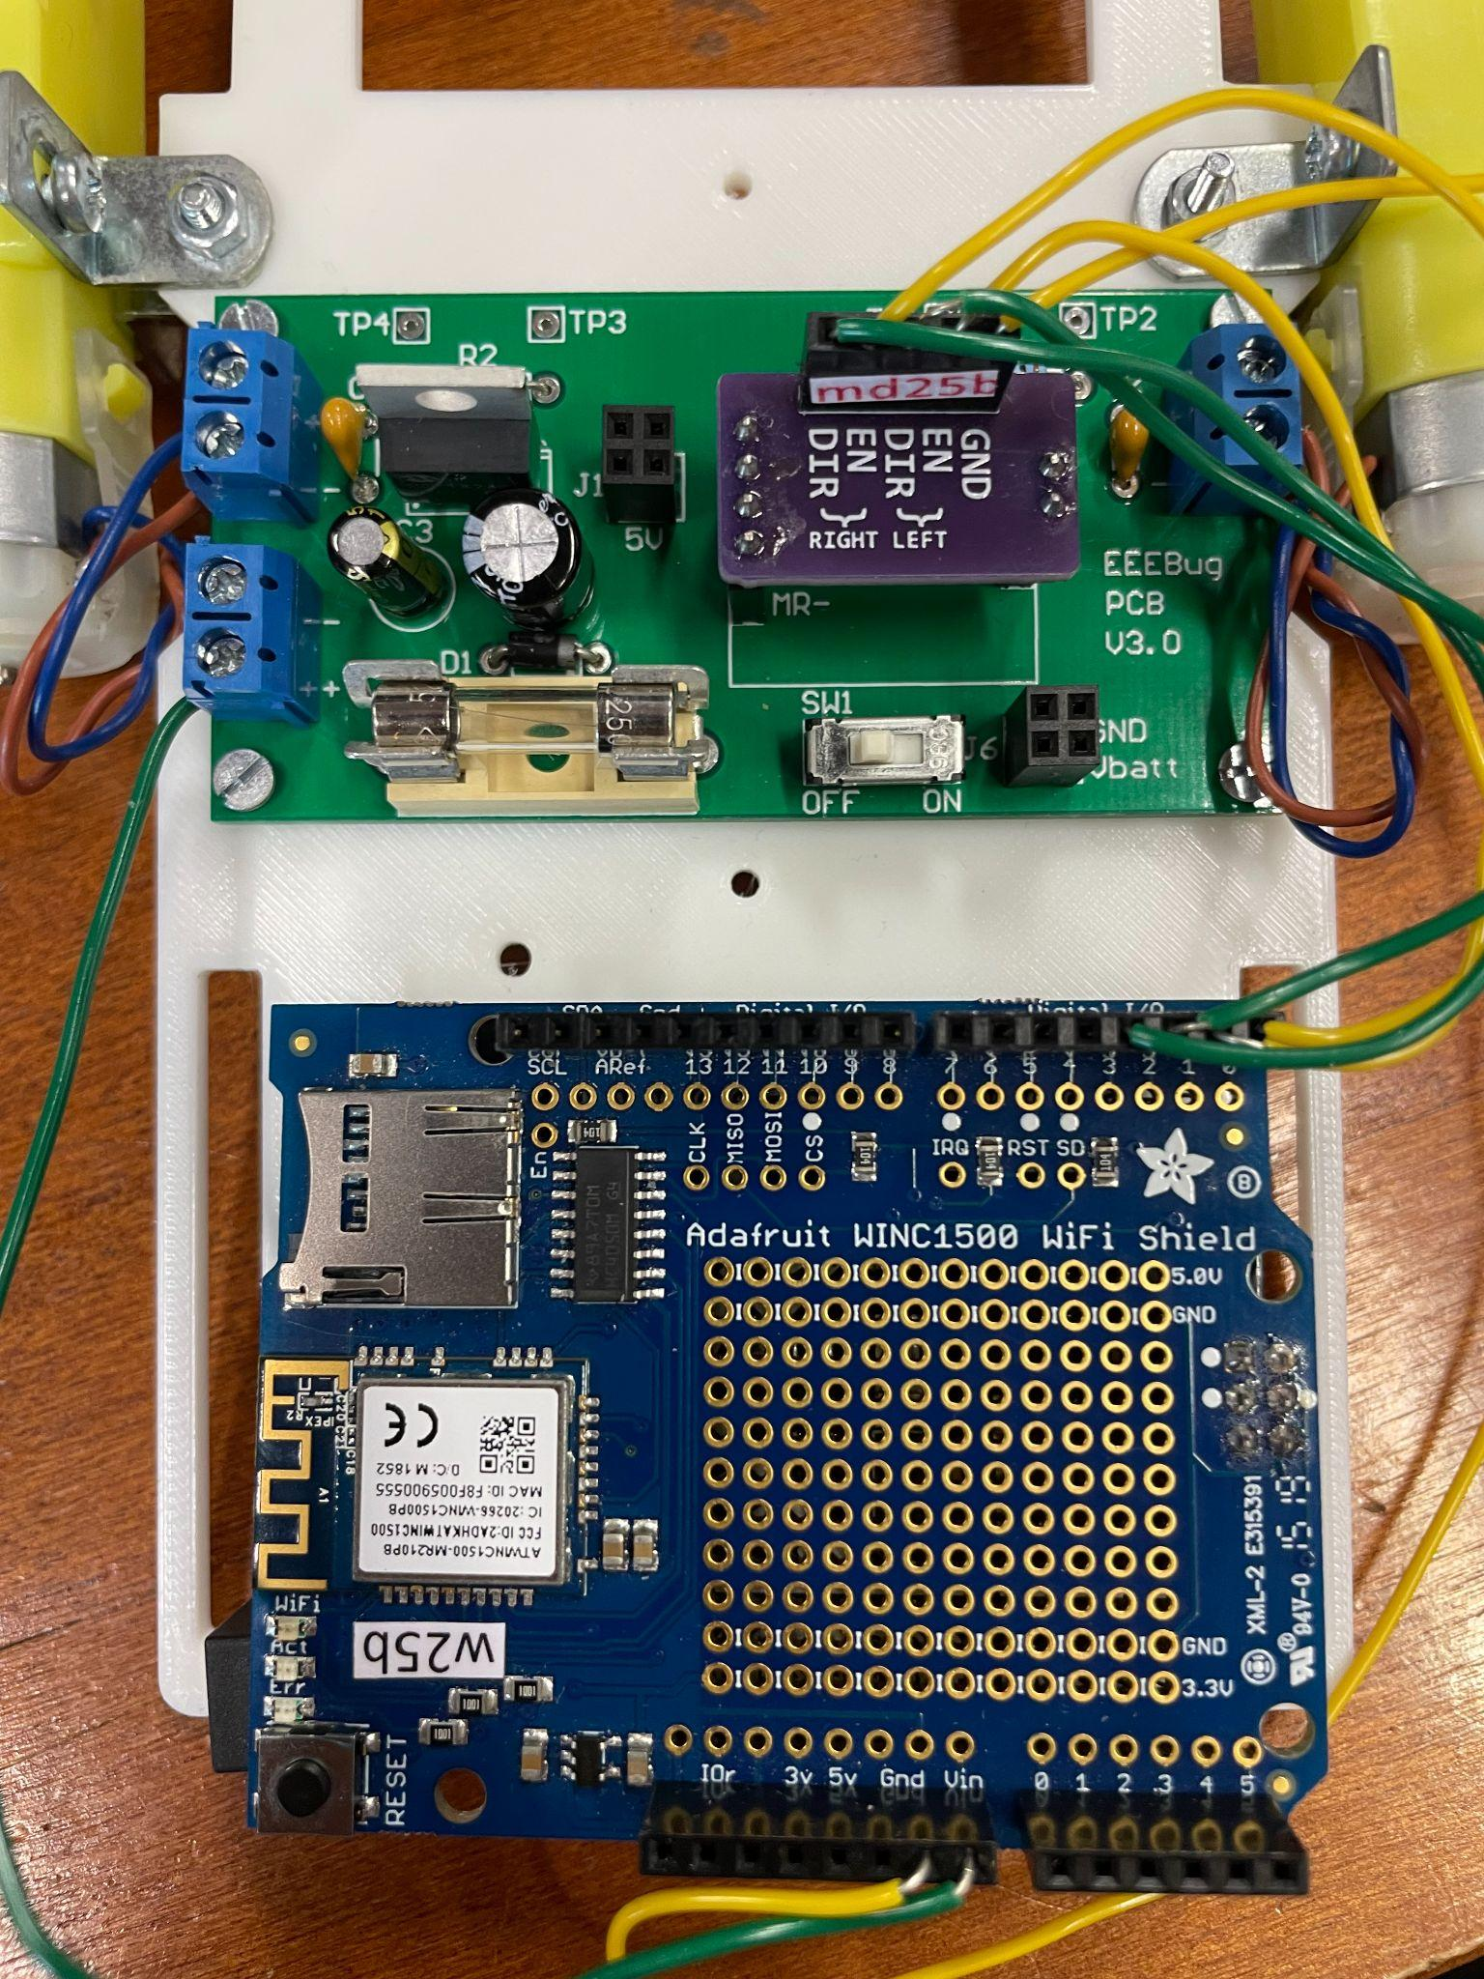

In terms of our motor driver, as shown in the image above, the TC78H620 module conveniently has a ENABLE and DIRECTION pin for the left and right motor separately. The ENABLE pin controls the speed of the motor, particularly its Pulse Width Modulation (PWM). To do so, the pin will have to be connected to one of the digital pins of the Arduino board with a PWM output function, which includes any of pins 3, 5, 6, 9, 10 or 11, according to the schematic. Then, in the code, an “analogueWrite()” function is used, which writes a value as a digital PWM signal, used to control the motor speed.

The DIRECTION pin essentially controls the direction which the motor is rotating in, which is achieved using a “digitalWrite()” function that writes either HIGH or LOW into the Arduino. A HIGH input means the motor will rotate clockwise, while a LOW input would make the motor rotate anti-clockwise.

In the section “Joystick and Motor Movement” below, we will cover how this motor design is applied into the rover as a whole, and also how the movement of the rover will be controlled to navigate the terrain.

**2.3. Software Development:**

**2.3.1 Name Detection:**

We were initially told that the name of each of the aliens will be transmitted in the form of ASCII characters which are then framed as UART and then modulated with radio frequency. The diagram below demonstrates how the appearance of the radio signals are expected to be like:



Abstract image showing Radio waves and their corresponding binary values

The diagram below is what the signals ended up looking like:

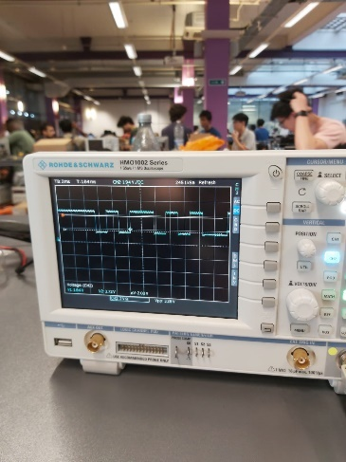

35-Actual outcome of radio signals

Once the infrared sensor was constructed, the main aim was to find a fast and time efficient way to store the frequency readings and convert it into its corresponding ASCII values. We then had to develop an algorithm that’ll be able to detect the start bit and consecutively store readings until the stop bit has been received.

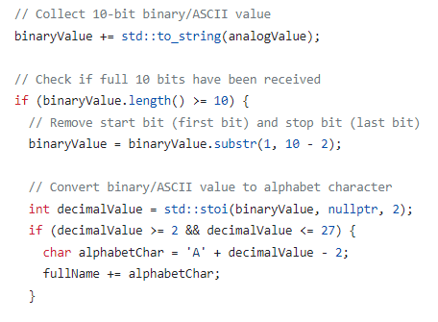Our main aim was to find a method which’ll allow us to use Interrupts within our program to use the algorithm at the right time. Initially the frequency of the timer had to be set for sampling and a compare register value was calculated. Throughout the Rover’s operation the compare register is compared to the timer count and once they match the interrupt flag is cleared and the analogue value is read and returned in order to start decoding the name.

Algorithm showing how the binary code is converted into ASCII

The most important function, decodeName() will initially define the signal and sampling frequency constants. It’ll call the functions needed to initialise the interrupts. Once the interrupt is due, the Algorithm is performed to detect the start bit, repeatedly add bits to a string variable and end once the required bit length is reached and the stop bit has been received (as shown to the right). Binary value is then converted into its ASCII value. This process will repeat until the full name has been repeated twice (as shown below). This is when we know the full name has been acquired. Once this is done the original name is returned and then outputted onto the UI. 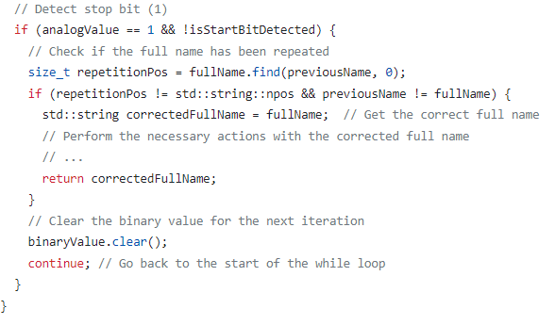

36- Algorithm showing how Correct name is detected and returned37Algorithm showing how Correct name is detected and returned

The functions used for handling the interrupts provide several advantages in the context of the given code. First, we’re able to dynamically set the frequency of the timer used for sampling without having to modify the rest of the code. The startTimer function can be called in other parts of the code, promoting modularity and reusability. By promoting the use interrupts, we are allowing the code to asynchronously respond to events triggered by the timer, in this scenario is when the compare register matches the timer count. This’ll prevent the need for any busy waiting and allows the Arduino to perform other tasks while waiting for the interrupt to occur, therefore improving the overall efficiency and responsiveness of the code.

The code responsible for performing these tasks can be found in name.h.

**3.2 Joystick/Motor Movement:**

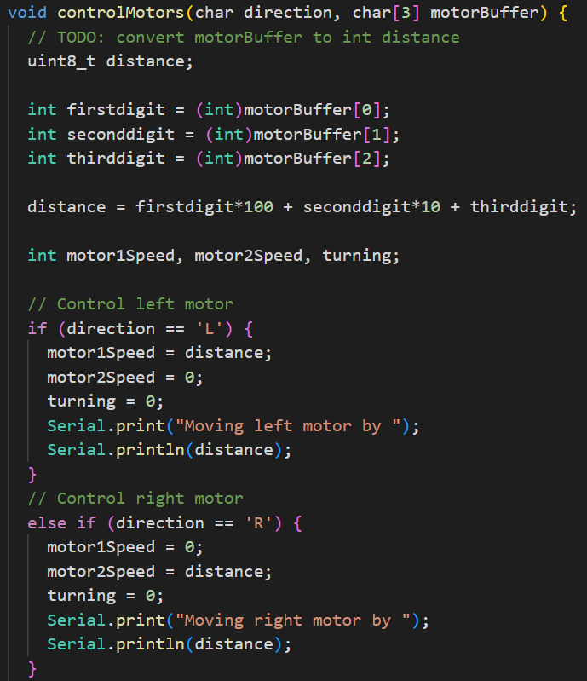Our initial design in controlling the rover was to test out the User Datagram Protocol (UDP) system but manually sending a 5-index packet from the main. One of the indexes will involve a command on the direction which the rover travels, while the other 3 is converted to a 3-digit integer which determines the distance travelled in that direction. A snippet of how the function is called from our main is shown on the right. This function will also be analysed in detail in section 3.5 User Interface and Remote Control.

Figure . Motor control code

This was obviously not suitable for our final design since the range of movement of the rover was solely restricted to left, right, forwards and backwards, in addition to the fact that it was extremely inefficient to manually send packets to the Arduino.

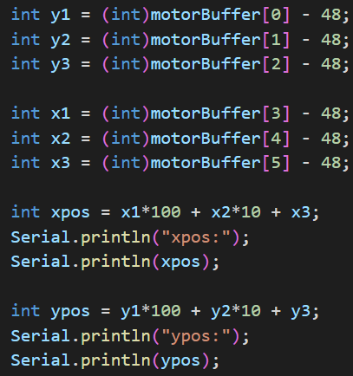Therefore, the movement system was modified by utilising a joystick design. This was made from a Python desktop application with a graphical interface which automatically generates packets based on the position of the joystick. This allows the rover to move freely within our control of the joystick.

Figure 9 . Motor control code

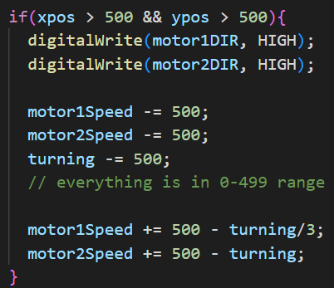The joystick is mapped from 0 to 999 in the x and y coordinate plane, where the “centre point” of the joystick, where the rover is designed to be stationary, is (500, 500). This drastically improved the movement of the rover because instead of manually sending packets to the main, the coordinates of the position of the joystick are automatically sent. This is then read by the modified Arduino code and is strategically mapped to control the movement of the rover in relation to the joystick. The image to the left shows how the new packets is converted to the direction and speed of the rover. The characters in the packets are converted into integers by subtracting 48. This is because, for instance, if the character “3” is converted, its ASCII code is 51, which means it needs to be subtracted by “0”, with an ASCII code of 48 to obtain the actual integer of 3.

40Figure 10 . Motor control code

This is accomplished by separating the joystick into 4 quadrants, similar to a unit circle, which determines the relative speed of each motor. For example, in the image to the right, in the first quadrant, both the x and y coordinates are larger than 500, and the rover is expected to travel forwards and towards the right, depending on its position. The coordinates are then subtracted by 500 each to get a range of 0-499. Then, x-coordinate values, which represents the turning factor, determine the relative speed of the left and right motors using a custom algorithm that considers the 0-499 range of values. Finally, the motor speeds are mapped into the appropriate range for the Arduino, which is 0-255. More on how the rover receives the packets is shown in 3.6 Rover Control.

The code responsible for performing these tasks can be found in movement.h.

**2.3.3 Polarity Measurements:**

For the purpose of polarity measurements a 3-axis magnetometer is used. The MCU uses the I2C interface to read data from it. Due to the weak magnetic field of the alien’s it was determined that more accurate measurements can be performed if the Earth’s magnetic field is accounted for. This is performed by measuring the y-axis magnetic field intensity while in the final orientation before approach to the alien and updating reference value of magnetic field intensity. If after approaching the alien the magnetic field in the y-axis does not change significantly from the value recorded during calibration the rover will output “neutral” once a command to measure polarity is received. If the value is significantly higher than the reference value it will output “N up”. If it is significantly lower it will output “N down”.

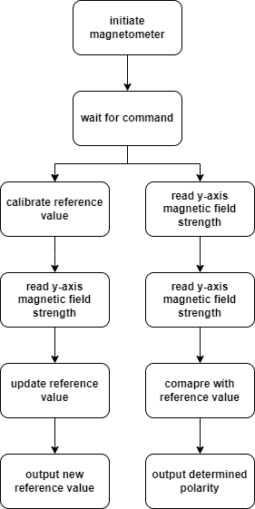

Figure 11. Polarity measurement flowchart

The code responsible for performing these tasks can be found in polarity.h.

**3.4 Age Detection:**

The Arduino code produced in this situation will take in the pulses detected by the infrared receiver in order to calculate the age.

Summary of functions used:

* detectPulse(uint16_t avg_voltage) - Once it has been defined it’ll take an average voltage value as the argument and return the time in microseconds when a pulse is detected. It reads the current voltage value from the IR receiver in and then enters a loop that keeps reading the current voltage and previous voltage as well as calculating the average voltage. until a condition is met. The condition will check if the current voltage is greater than the average voltage and whether the previous voltage is less than or equal to the average voltage. If this condition is met then the current time in micros is assigned to a variable called ‘time’ and is then returned for further usage.
* readAge() - Main function used to read Alien’s age and return the calculated age in years.
  + The IR receiver pin is set as an input pin and calibration is performed to determine the average voltage value by reading from the pin for a certain calibration time.
  + During calibration the voltage readings are added to a variable called ‘voltage sum’ and increments ‘calibration_ctr’. After the calibration time it then calculates the ‘avg_voltage’ by dividing the sum of voltages by the calibration count.
  + detectPulse() function is called and assigns the returned start time to ‘start_time’. It’ll then enter a loop and call this function in order to assign the returned end time to ‘end_time’ for a specified number of pulses.
  + The age is calculated by dividing the time duration (end_time - start_time) by the number of pulses and dividing it by 10. The result is rounded and then assigned to the variable ‘age’ which is then returned.

The code responsible for performing these tasks can be found in age.h.

**3.5 User Interface and Remote Control**

An essential property of the rover system developed is a reliable control system through which the rover can be remotely controlled. Three approaches for the fundamental structure of this system have been considered:

1. **Communication via HTTP where the rover is the server and a laptop or phone is the client:** This approach is easy to implement but uses up a lot of the limited memory and computational resources of the Cortex-M0 MCU. Commands cannot be sent with high frequency.
2. **Communication via HTTP where the rover is the client and a laptop is the server:** This approach is tricky to implement but reduces the resource usage on the MCU. Commands cannot be sent with high frequency.
3. **Communication via UDP with no specific client/server distinction:** This approach is easy to implement and greatly reduces the resource usage on the MCU. Commands can be sent at a high frequency. Due to limited reliability of UDP preventive measures have to be implemented in case a packet is not delivered.

The approach utilising UDP was chosen due to its high speeds, low resource utilisation and higher resemblance to the actual protocols used to control rovers in deep space. Due to long communication delays it is not possible to use a protocol like HTTP/TCP which requires multiple data exchanges before a single packet is transmitted.

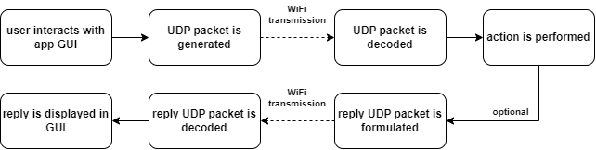

Figure 12 . WiFi communication schematic

A simple custom protocol was developed to facilitate efficient communication between the desktop application and rover. This protocol is used only to transmit commands to the rover. Replies from the rover consist purely of numerical values encoded as chars or of a series of chars which together form a word such as an alien’s name.

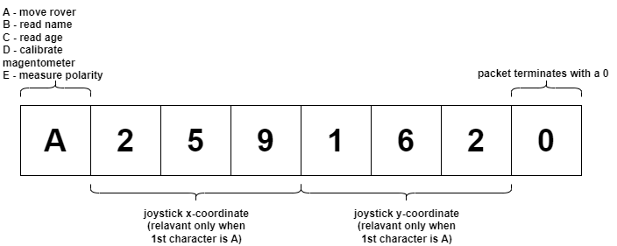

Figure 13 . UDP packet structure

A desktop application with a graphical user interface (GUI) which allows for intuitive control via an animated virtual joystick and buttons was developed. The main function of the application is the automatic encoding of commands using the custom protocol, their transmission to the rover and handling of replies from the rover. The application was written in Python using the PyQt library for animating the joystick movement and defining interface layout, socket for managing UDP communication and threading to facilitate concurrent execution of tasks. The application features timeouts and other redundancy features to ensure that UDP packets are correctly transmitted and instances where a command or reply has not been received are handled.

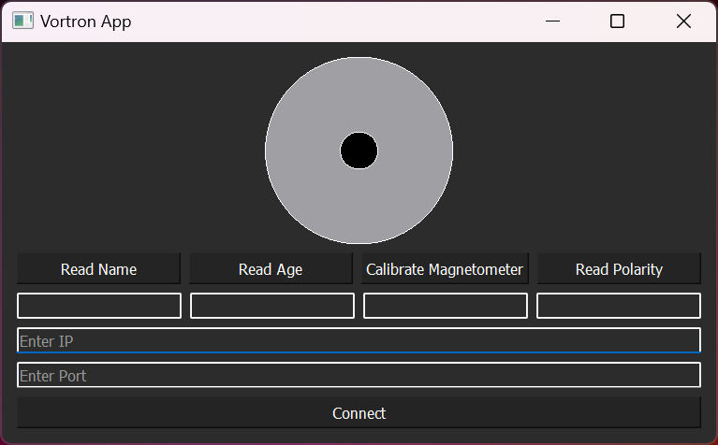

Figure 14 . Desktop application

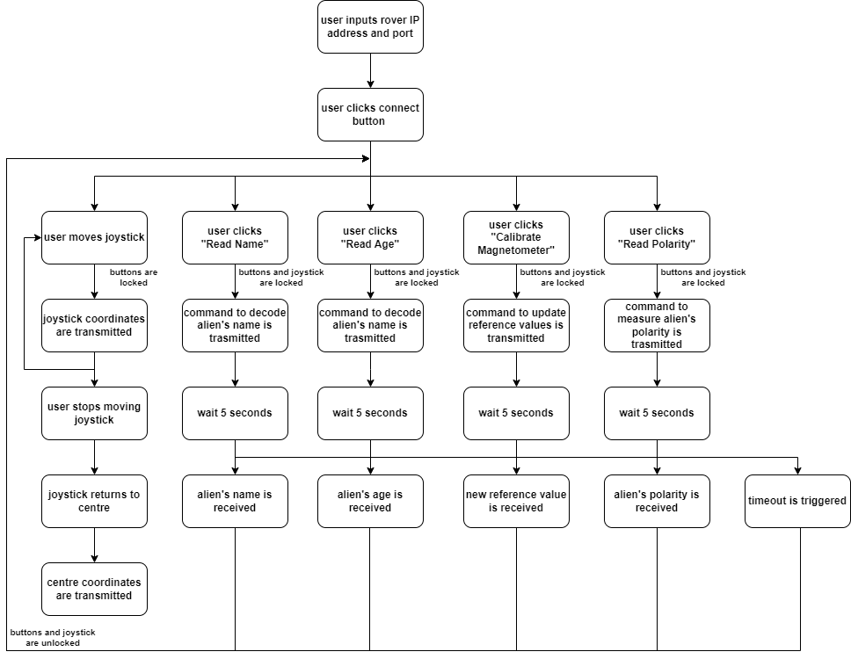

Figure 15 . Desktop application flowchart

Code containing the Python implementation of the desktop application can be found in app.py.

**3.6 Rover Control**

A process complementary to the one performed by the application must be performed by the Cortex-M0 MCU on the rover. This must allow for the decoding of received commands, execution of correct functions and sending reply to packets. Such a system was implemented in C using the WiFi101.h library to interfacing the WiFi shield, WiFiUdp.h for handling sending and receiving UDP packets.

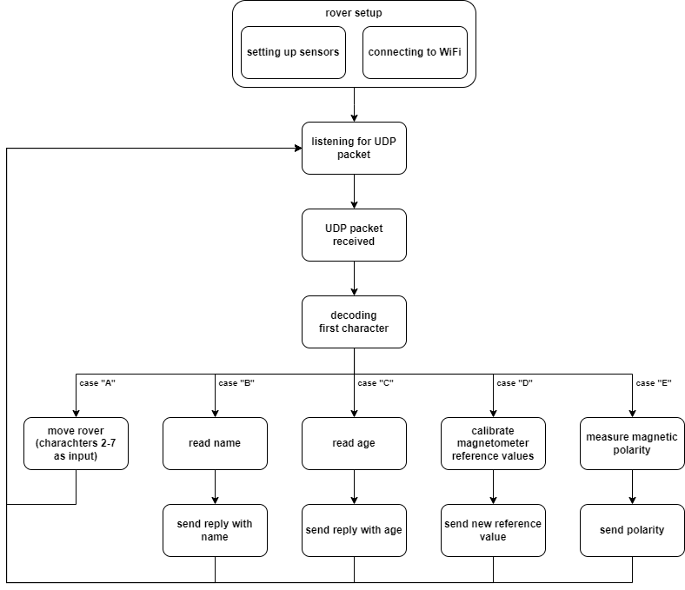

Figure 16 . Rover control code flowchart

The code responsible for performing these tasks can be found in main.cpp.

**4. Discussion**

The past few sections show an overview of the contributions in both the hardware and software sides to the design. We have thoroughly tested the rover to confirm it agrees with the agreed standards.

All subcomponents and subsystems have been tested individually to ensure that they meet the specification required.

**Movement tests:**

With the use of the desktop application and virtual joystick the motor control and communication subsystems were tested. The following objectives were evaluated:

* Rover moves forwards - PASSED
* Rover moves backwards - PASSED
* Rover turns right while moving forwards - PASSED
* Rover turns left while moving forwards - PASSED
* Rover turns right while moving backwards - PASSED
* Rover turn left while moving backwards - PASSED
* Rover rotates clockwise while remaining in place - FAILED (due to rear wheel)
* Rover rotates anticlockwise while remaining in place - FAILED (due to rear wheel)
* Rover remains stationary after joystick is left go - PASSED

A redesigned rear wheel will be implemented to counter the issues encountered.

**Name decoding tests:**

Due to delays with the construction of the analog filtering and amplification circuitry required for name decoding a full name decoding process has not yet been performed. Instead the circuitry was tested separately with the use of oscilloscopes and a function generator. As of the time of writing of this report the circuitry is being soldered on a stripboard.

The code was tested in two ways:

* Acquisition of test signal generated with function generator - PASSED
* Decoding of name from manually generated data resembling and acquired signal - PASSED

**Age decoding tests:**

Age decoding tests were performed by placing an IR receiver near an alien and reading the output of the code. The alien’s age was read to be 610 years which was confirmed through manual measurements with the use of an oscilloscope. Tests prove that the system developed can read an alien’s age with the required accuracy of a decade and produces reliable results unless placed too far from the alien.

**Polarity measurement tests:**

With the use of small magnets, the code for interpreting magnetometer readings was tested. The following results were obtained.

|  |  |  |
| --- | --- | --- |
| Condition | Output | Outcome |
| N facing up | up | PASSED |
| N facing down | down | PASSED |
| no magnet | neutral | PASSED |

Due to the fact that some tasks are still being concurrently finalised and the rover is being assembled as of the time of submission of this report a complete simultaneous test of all subsystems has not yet been performed.

The following tasks must be completed prior to the demonstration as of the time of writing of this report:

* Replace rear wheel with a design that rotates in place
* Replace FXOS8700 magnetometer with QMC5883L
* Solder all circuitry permanently to a stripboard
* Finalise construction of rover
* Perform final tests of whole system in arena

The tasks that are yet to be performed can be realistically achieved within 4 days ahead of the rover presentation.

**5. Conclusion**

Significant progress has been made since the beginning of the Project period. This is only a result of our strong teamwork ability as well as our individual skill. The different results acquired throughout the project indicates the EERover’s ability to perform the desired actions but there is always going to be room for improvement. This starts with finalising the final model of the Rover and ensuring the different software programs produced will be able to pass as many different test cases as possible. Once the hardware is fully complete and we are fine with the reliability of the software, our plan will be to examine any areas of improvements, enhance the EERover and continue to test it to ensure it’ll operate at its best.

**References**

**Part 1:**

Electrical4U (n.d.). *Schmitt Trigger: What is it And How Does it Work? (Circuit Diagrams Included) | Electrical4U*. [online] https://www.electrical4u.com/. Available at: <https://www.electrical4u.com/schmitt-trigger/>.

Reference to free given chassis : Ed (2023). *EEE1labs*. [online] GitHub. Available at:

https://github.com/edstott/EEE1labs/blob/main/skills/graphics/EEEBug-assembly-part1.pdf.

‌

Free expansion kit components at: Ed (2023). EEERover Specifications and Technical Guide. [online] GitHub. Available at: https://github.com/edstott/EEERover/blob/main/doc/README.md.

EEEGUIDE.COM. “Precision Rectifiers | Inverting | Noninverting half wave rectifier.” EEEGUIDE, https://www.eeeguide.com/precision-rectifiers/. Accessed 15 June 2023.

Renesas. “ICL7660 Datasheet.” Renesas, 5 October 2010, https://www.renesas.com/eu/en/document/dst/icl7660-datasheet. Accessed 15 June 2023.

Rutgers university. “The Envelope Detector.” WINLAB, Rutgers, Jim Lesurf, https://www.winlab.rutgers.edu/~crose/322_html/envelope_detector.html. Accessed 15 June 2023.

**Part 2:**

Phototransistor explanation :Electrical4U (n.d.). *Phototransistors: What Are They & How Do They Work? | Electrical4U*. [online] https://www.electrical4u.com/. Available at: https://www.electrical4u.com/phototransistor/.

Hall sensor explanation : Explain that Stuff. (2018). *How Hall effect sensors and probes work*. [online] Available at: https://www.explainthatstuff.com/hall-effect-sensors.html.

**APPENDIX:**

**Appendix 1: GitHub Repository**

https://github.com/kindakwiatek/Vortron

**Appendix 2: Gantt Chart**

29/05/2023(Plan for week)

|  |  |  |  |  |  |  |  |
| --- | --- | --- | --- | --- | --- | --- | --- |
| name | Mon | Tue | Wed | Thurs | Fri | Sat | Sun |
| Mohammed | Building circuit on breadboard and testing | | | |  |  |  |
| Rares | Design of wheel | Chassis design | | | |  |  |
| Sebastian | Decoding infra-red | Waiting for hall sensor | Constructing antenna as well as hall sensor | | |  |  |
| Steve | Overseeing the Arduino codes for detection | | | | |  |  |
| Justin | Chassis | | Polarity Code | |  |  |  |
| Chris | Finalise Wifi code and begin UI | | | | | | |

Actual(29/05/2023)

|  |  |  |  |  |  |  |  |
| --- | --- | --- | --- | --- | --- | --- | --- |
| name | Mon | Tue | Wed | Thurs | Fri | Sat | Sun |
| Mohammed | Assembling and testing Positive to negative voltage converter | | Assembling rectifiers and troubleshooting.  Preparing for presentation | | Final touches to Presentation | | |
| Rares | Improving chassis | Not in | Printing prototype chassis | Writing report | Writing report and troubleshooting chassis | Report writing | |
| Sebastian | Improve the antenna | Improve the antenna | Creating the coil | Assisting Team members | Assisting Team member | | |
| Steve | Arduino programming | | | Report writing | | | |
| Justin | Chassis | | Modifying movement code | | | | |
| Chris | Finalise Wifi code, finalise IR code, begin UI and support team members | | | | | | |

Plan(5/6/2023)

|  |  |  |  |  |  |  |  |
| --- | --- | --- | --- | --- | --- | --- | --- |
| Name | Mon | Tue | Wed | Thurs | Fri | Sat | Sun |
| Mohammed | Fix rectifier offset problem | | Smooth out signal for digital processing | | | Report | |
| Rares | Improving wheels | Writing report of wheels | | | | | |
| Sebastian | Improve the coil | Assisting team members | Assisting team members | Assisting team members | Assisting team members | | |
| Steve | Oversee Report | | | Test the name program | | | |
| Justin | Make joystick code | | Report | Assemble rover | | | |
| Chris | Constructing desktop application | | | | | | |

Actual(5/6/2023)

|  |  |  |  |  |  |  |  |
| --- | --- | --- | --- | --- | --- | --- | --- |
| Name | Mon | Tue | Wed | Thurs | Fri | Sat | Sun |
| Mohammed | Fix rectifier offset problem | | Make antenna | Passed signal through grounded RC and suitable low pass filter | | | |
| Rares | Managed to find faults in design of wheels | Report writing | Chassis Design | | | | |
| Sebastian | Improve the coil | | Make antenna | | | | |
| Steve | Constructed majority of the report | | | | | | |
| Justin | Made joystick code and report | | | | | | |
| Chris | Constructing desktop application and finalising magnetometer code | | | | | | |

Plan (12/06/2023):

|  |  |  |  |  |  |  |  |  |  |
| --- | --- | --- | --- | --- | --- | --- | --- | --- | --- |
| name | | Mon |  | Tue | Wed | Thurs | Fri | Sat | Sun |
| Mohammed |  | Finalising IR Sensor Circuit | | | | Finalising Report | Assemble and test Rover | | |
| Rares |  | Printing off several components for Rover | | | Finalise Report | | Assemble and test Rover | | |
| Sebastian |  | Finalise Report | | | | | Assemble and test Rover | | |
| Steve |  | Finalising Report and testing Name algorithm | | | | | | | |
| Justin |  | Test Motor Control | | | | Finalise Report | Assemble and test Rover | | |
| Chris |  | Finalise UI and support Motor Control | | | | Finalise Report | Assemble and test Rover | | |

Actual (12/06/2023):

|  |  |  |  |  |  |  |  |
| --- | --- | --- | --- | --- | --- | --- | --- |
| name | Mon | Tue | Wed | Thurs | Fri | Sat | Sun |
| Mohammed | Finalising IR Sensor | | Test Name Algorithm | Finalise Report |  | | |
| Rares | Improve chassis design | | | Finalise Report |  | | |
| Sebastian | Support Report | | | Finalise Report |  | | |
| Steve | Finalise and test Name algorithm | | | Finalise Report |  | | |
| Justin | Test Motor movement | | | Finalise Report |  | | |
| Chris | Test Motor movement and UI | | | Finalise Report |  | | |

**Appendix 3: Work Breakdown Structure**

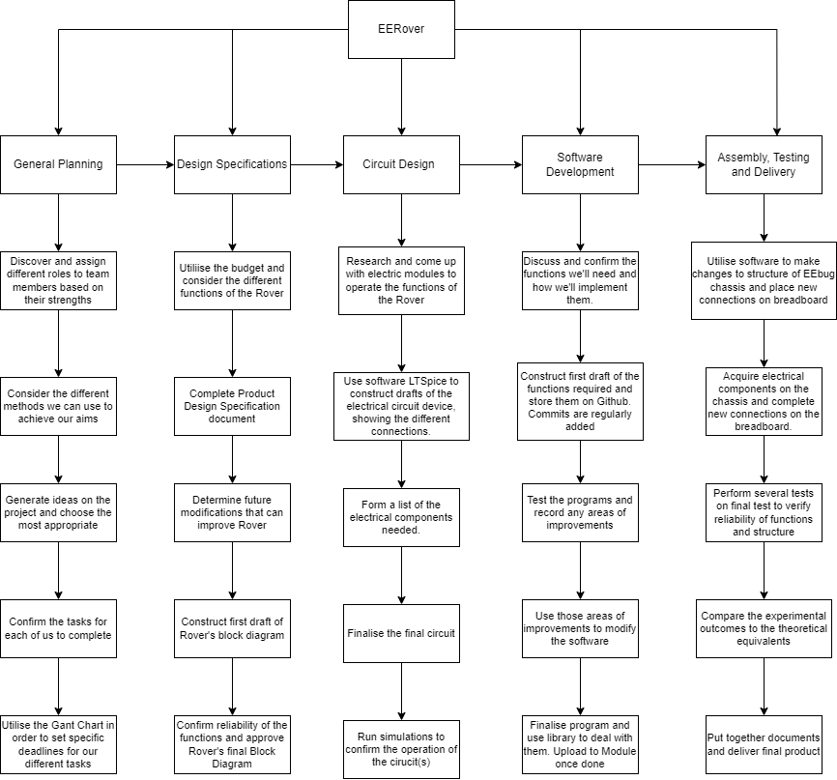

**Appendix 4: Product Design Specification**

**Project: EERover Author: Team Vortron**

**1. Performance:**

We must consider how speed and endurance can influence the battery efficiency. Sensors (for radio frequency, infrared and magnetic field) are expected to work effectively and accurately especially when dealing with interceptions. Rovers also expected to operate remotely with responsive control. This can only be done if the connection over Wi-Fi is stable and fast.

**2. Environment:**

Should work in the following conditions:

* Temperature - Pressure
* Humidity - Gravity Forces
* Wind - Dust & dirt

In this scenario the Rover’s functionality is top priority but the EERover should be designed to overcome these conditions. Most importantly, we expect the Rover to smoothly travel and navigate across smooth surfaces.

**3. Life in Service:**

The EEErover must be designed to last long enough for testing and the specified consumer’s time of usage. Previous designs of the rovers are manufactured to last for 2 years, so we aim for a similar length of time. Thus, only 2 motors were used instead of 4 for optimal power consumption.

**4. Maintenance:**

Once EERover has been built and launched it won’t be maintained meaning it’ll last with its initial components for the period of use as long as it is not exposed to corrosion and other environments that will cause components to wear down.

**5. Target Product Cost:**

Budget for the project is £60, no need to include any launch costs and mission running costs as the rover will be only used in lab (controlled environment)

**6. Competition:**

Copying the design of another patent is against the rules so it’s important to ensure our designs are unique compared to the other patents. The rover must outperform the other contestants’ models.

**7. Shipping:**

How the product is delivered must be strongly considered to minimise costs. Shipping methods are also important since we need to make sure the deadlines are met, and it doesn’t end up damaging the product. Disassembly may be required to secure sensitive parts of the rover, and packaging must provide structural support to the rover and must be sturdy.

**8. Packing:**

If components are shipped by…

* Sea then the packaging must be waterproof.
* Air then the packaging must be shock proof, light and must comply with air travel regulations.

**9. Quantity:**

We’ll only produce a single Rover as our final product, but several prototypes will be made before reaching this stage.

**10. Manufacturing Facilities:**

As a result of the bespoke nature of our product it may be necessary to build the product on a small scale. Money could be saved if we were to outsource the production of component parts and assemble them on our own.

**11. Size:**

EERover must be small enough to fit on the scale of the platform but also big enough to leave space for all sensors as well as the PCB. Designs must include lightweight designs in all areas. Weighing scale is repeatedly used to make sure the weight satisfies our conditions.

**12. Weight:**

Rover s components were designed to be as light as possible by narrowing our options of materials to low density types and by minimising circuitry mounted on the rover.

**13. Aesthetic Appearance & Finish:**

Not the most important in our priority list as we care more about the functionality. However it’s important to protect any exposed cables and provide some aesthetic features but they’ll need to be as cheap as possible to maximise cost efficiency.

**14. Materials:**

We expect the materials used to be…

* Strong - Light
* Compact - Cost effective

Materials shouldn’t interfere with any of the sensors so in case we use metals then they should at least be non-ferromagnetic.

**15. Product Life Span:**

EERover’s not expected to last an incredibly long amount of time. Electromigration in the microcontroller may damage and cause malfunctions in pins of microcontroller.

**16. Standards and Specifications:** When designing the rover considerations should be met to ensure safety, functionality, and compliance with industry best practices.

**17. Ergonomics:**

Rover was designed for ease of use for the client by choosing easy control of its movement through a simple app programmed in Python, and recording of measurements is automatically done and formatted clearly on the computer.

**18. Customer:**

Every component of the rover must be accessible to the customer for any adjustments to personal preferences and must be easy to use. All specifications must be met such as accurately determining age, name and magnetic field of the alien. Code must be annotated with comments for guidance and thorough explanation.

**19. Quality and Reliability:**

Circuits must be able to filter noise for accurate signals to be received and sensors must be placed at optimal positions for receiving the signals as fast as possible.

**20. Shelf Life:**

-Low power consumption means the battery can last for years.

-Temperature of components must be kept low so that soldering points do not degrade

-Capacitors must be checked if stored for long periods of time.

**21. Processes:**

Sensors are placed spaced away from each other since the radio receiver (inductor coil) may interfere with the Hall probe when detecting the magnetic field of the alien. Any circuit on breadboard must be on separate places for clear identification and wires must be short to reduce weight and colour coded to allow ease of identifying errors.

**22. Time Scale:**

The summer project started on 12/05/2023 and the completion of the rover is due 20/06/2023 (around 6 weeks to complete). In the first two weeks our team organised the roles of each member and planned the design of each feature of the prototype. Our objective is to finalise the project one week in advance of the scheduled demonstration to allow for troubleshooting and potential improvements.

**23. Testing:**

All required components are assembled on chassis well before examination date to fix bugs in code and evaluate rover’s overall performance. Connections on strip boards are regularly checked for misplaced components.

**24. Safety:**

Circuits on the breadboard may be easily moved which can damage the rover’s functions, so additional casing must be considered as well as minimising exposure of electrical components that could come in physical contact with the consumer. Other hazards such as high voltages or sharp edges must be specified in a Safety Guideline.

**25. Company Constraints:**

Mass must be under a specified limit, which can limit potential components added to the rover to improve its performance, thus narrowing available choices of design.

Software must be efficient for accurately determining the alien’s features in a short time, so restrictions must be enforced when programming the Arduino board.

**26. Market Constraints:**

Composed of world leading professionals, we expect to be given suggested improvements on our design and technical sources of error we have made when designing the rover, based on the same criteria as in the Company Constraints section.

**27. Patents, Literature and Product Data:**

Programming was done by our members of the team who possess expertise in this domain. Circuitry may have been inspired from existing ones such as envelope detectors and H bridges, which we aim to specify in the rover handbook.

**28. Political and Social Implications:**

The rover may have commercial implications outside its manufacturing purpose such as a design idea for introducing children to finding hidden toy aliens around their surroundings which could help the government to encourage young generations in the technology industry. This can also raise money to improve the economy.

**29. Legal:**

Specific Product Regulations (SPR) were taken into account when designing the rover, and any feature was designed such that it does not breach any UK safety standards.

**30. Installation:**

We aim to hand the rover fully installed to the user to minimise difficulties. The motor driver module is placed in between the two motors in the centre of the chassis. At the front of the chassis the sensors will be placed with spacing between each other to minimise interferences with each other. The metro board and breadboard have specific insertion screw holes specific for their size and place on chassis.

**31. Documentation:**

A detailed specification of the components used must be given in the documentation of the final design, preferably with links to their respective datasheets. Schematics of each circuit design used must be given with detailed explanation for their roles in identifying the name, age, magnetic field and control of the rover as well as consumer health and safety measures such as GPSR

**32. Disposal:**

Batteries must be disposed appropriately as they contain hazardous chemicals such as lithium-ion batteries may be reacted when exposed to extreme conditions. Any other component of the rover may be recycled or reused if not damaged.